Ministry of Forests, Lands & Natural Resource Operations | Coast Forest Area  2100 Labieux Road  Nanaimo, BC, V9T6E9
Visual Quality Objective Conformance Monitoring of the Discovery Islands
Campbell River and Sunshine Coast Forest Districts
January 17, 2014

-Working Draft-

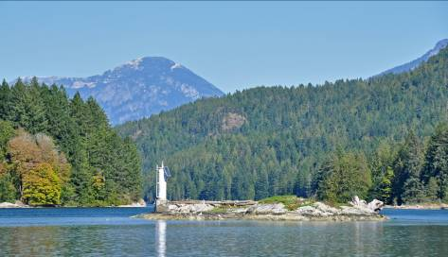

Prepared by
Lloyd Davies, RPF
Visual Resource Management Specialist
Coast Forest Area

Introduction

The purpose of the in-field visual resource monitoring within the Discovery Islands was to evaluate the overall level of conformance of forest harvesting to the established Visual Quality Objectives. The report documents the current visual condition, overall level of conformance, and identifies any specific areas of concern. The project was jointly promoted by the Ministry of Forests, Lands & Natural Resource Operations (MFLNRO) and Ministry of Jobs, Tourism & Skills Training (JTST). Initiation of this broad scale conformance monitoring was in part to concerns being expressed by the Discovery Islands Marine Tourism Group.

Study Area
The Discovery Islands is a descriptive term used to define a group of islands between Vancouver Island and the Mainland of BC, starting near Campbell River and running slightly north of Sayward in latitude. It is generally considered to encompass the following major islands: Quadra, Cortez, Read, Maurelle, Sonora, Stuart, East Thurlow, West Thurlow, Raza, West Redonda, and East Redonda. The area has a large number of scenic marine passages, including Johnstone Strait, Okisollo Channel, Hole in the Wall, Whiterock Passage, Sutil Channel, Calm Channel, Pryce Channel, Cordero Channel, and a number of smaller passages, arms, and bays. Portions of the fiord landscapes of Bute Inlet and Toba Inlet were also reviewed. It is a group of rugged coastal islands and marine passages known widely for their scenic attractiveness. The area provides the foundation for a provincially significant amount of public recreation and commercial tourism. The Discovery Islands’ natural beauty is also highly valued by the local residents of the islands. At the same time, the area is heavily forested and supports a large forest industrial base. For the purposes of the field monitoring, all areas shown on the map Appendix 1 were reviewed.

Methodology

In-field monitoring was completed during September 4-15, 2013. Dates were chosen for optimal weather, lightening, and ocean conditions. Travel was by MFLNRO vessel and water taxi to duplicate a recreation/tourism boating experience. Forty hours were logged on the water. A digital SLR camera with GPS capability was used to record the landscape scenes. In total, over 750 digital photographs were recorded. Each photograph was geotagged with its gps location.
Personnel
Planning and in-field visual monitoring was completed by Lloyd Davies, RPF, Visual Resource Management Specialist for the Coast Forest Area. Staff support and local knowledge within the Campbell River District was provided by John Andres, RPF, Stewardship Officer. Staff support and local knowledge within the Sunshine Coast District was provided by Blake Fougere, RPF, Stewardship Officer and Gerard Nachtegaele, RFT, Resource Technologist, Tenures. See Appendix 3 for MFLNRO staff contacts.

Visual Quality Objectives

Visual Quality Objectives (VQOs) are forest management objectives established by a district manager under the Government Action Regulation section 7 (2). They are used to reflect society’s desired level of visual quality on the landscape. The Forest Planning and Practices Regulation section 1.1 defines 5 categories of alteration:

- Preservation: consisting of an altered forest landscape in which the alteration, when assessed from a significant public viewpoint, is
(i)Very small in scale, and (ii) not easily distinguishable from the pre-harvest landscape;
- Retention: consisting of an altered forest landscape in which the alteration, when assessed from a significant public viewpoint, is
(i) difficult to see, (ii) small in scale, and (iii) natural in appearance;
(c) Partial Retention: consisting of an altered forest landscape in which the alteration, when assessed from a significant viewpoint, is
(i) easy to see, (ii) small to medium is scale, and (iii) natural and not rectilinear or geometric in shape;
(d) Modification: consisting of an altered forest landscape in which the alteration, when assessed from a significant public viewpoint, is
(i) is very easy to see, and (ii) is (A) large in scale and natural in its appearance, or (B) small to medium in scale but with some angular characteristics;
(e) Maximum Modification: consisting of an altered forest landscape in which the alteration, when assessed from a significant public viewpoint,
(i) is very easy to see, and (ii) is (A) very large in scale, (B) rectilinear and geometric in shape, of (C) both.

To assist with graphically understanding the categories of visually altered forest landscapes, see poster entitled: A Guide to Visual Quality Objectives.

MFLNRO Visual Resource Management program is overviewed in the publication “Managing Change on British Columbia’s Scenic Landscape. See link.

Additional resource material on the MFLNRO’s Visual Resource Management program can be found at the following website.

Once VQOs are legally established, forest licensees are responsible for ensuring their harvesting and road building is consistent. Government assesses conformance through random field monitoring under the Forest and Range Evaluation Program. . Cases of suspected non-compliance may also be investigated by MFLNRO Compliance & Enforcement staff. The current Discovery Islands VQO conformance review, while strategic in scope, is in part fulfilling the Ministry’s obligation to monitor resource practices under the Forest & Range Practices Act

Visual Quality Objective Status

Sunshine Coast District established their VQOs in May of 1997 under the Forest Practices Code. The VQOs were subsequently grandparented into FRPA by virtue of FRPA section 181 in December 2004.

Campbell River District established VQOs in December 14, 2005 through FRPA Government Action Regulation section 7 (2) order. It involved considerable input from forest licensees, general public, recreational stakeholders, and First Nations.

Table 1 Discovery Islands, Area by Established VQO class

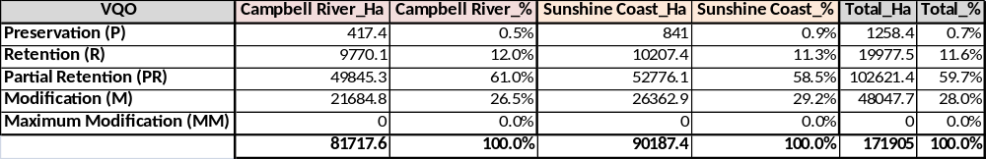
The above indicates the proportion of the Discovery Islands in the 2 districts is very similar. In addition, the distribution of area by VQO class is extremely close. The vast majority (60%) is Partial Retention. This is followed by 28% Modification VQO. A small (11.6%) but significant portion is the highly restrictive Retention VQO. Neither Preservation or Maximum Modification VQO are significantly represented.
Summary of Previous VQO Monitoring
Under theForest & Range Evaluation Program (FREP)

The MFLNRO uses procedures developed under the FREP program to monitor VQOs. Link The protocol procedures randomly select harvest blocks (under 3 years old) that fall within scenic areas with an established VQO. The chosen block is then used to identify the landform for review. Once a landform is identified and viewpoint(s) chosen, all harvest openings and road building are assessed for their cumulative visual impact. Sampling has been conducted in various years for the two districts with cutblocks approved under both the Forest Practices Code (FPC) and Forest Range Practices Act (FRPA). To date, a small sampling of 22 landforms have been assessed within the area of Discovery Islands.

Campbell River District total of 14 samples
86% conformance 14% non conformance (2 samples)
Sunshine Coast District total of 8 samples
87.5% conformance 12.5% non conformance (1 sample)

Combined results indicate a high level (86%) level of VQO conformance. This is slightly higher than the total Coast Area of 82% conformance based on 102 samples. And substantially better that the provincial averages under the FPC (63% conformance) and FRPA (69% conformance).

Findings: a Visual Monitoring Photographic Review

The following photographic review is presented in the order of travel. In other words, it follows no priority for visual impact significance. The first two field days were spent within the Campbell River District portion of the Discovery Islands. Subsequently, another 2 days were spent within the Sunshine Coast District. Each photograph “Stop” includes its geographical location, a note on the relative level of VQO conformance in the scene, and any relevant comments. For the benefit of online review each report photograph “thumbnail” is linked to a website housing full resolution images. Simply “click” on the individual photo thumbnail to review the image in detail. It is important to recognize that photographs are being presented in the report as a surrogate to actual on-site viewing. Photographs when reviewed at a very large scale of reproduction are generally regarded as a fairly reliable surrogate. However, readers are reminded that photographs cannot substitute for in-field review where the human scale, viewing context, and travel experience all play a part of the landscape perception.
The location of each Stop is shown on the map in Appendix 3. Select wall map for suitable large scale printing.
Stop locations are shown and can be reviewed on Google Earth:

(Stops 1thru 64 are located within the Campbell River Forest District)

Stop 1
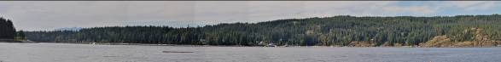
Herriot Bay, Quadra Island- natural appearing setting, good conformance to PR VQO.

Stop 2
Hyacynthe Bay, Quadra Island- natural appearing setting, good conformance to PR VQO

Stop 3
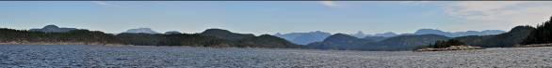
Hoskyn Channel- natural appearing landscapes, good conformance to VQOs

Stop 4
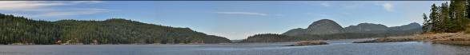
Freedom Point, Quadra Island- natural appearing landscapes, good conformance to VQOs

Stop 5
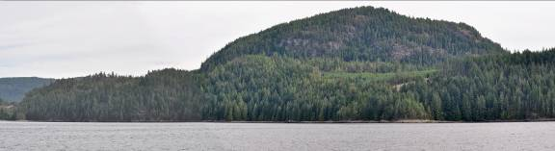
Hoskyn Channel- privateland logging, minor visual impact

Stop 6
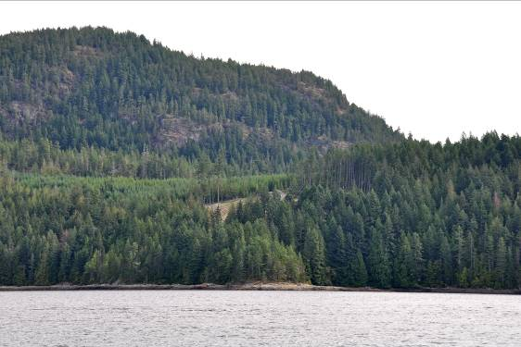
Hoskyn Channel- privateland logging close-up, minor visual intrusion, meeting the intent of PR VQO.

Stop 7
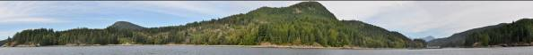
West entrance to Whiterock Passage, Surge Narrows Park- some old privateland logging that has visually greened-up. Crownland conforming to the Retention VQOs.
Stop 8
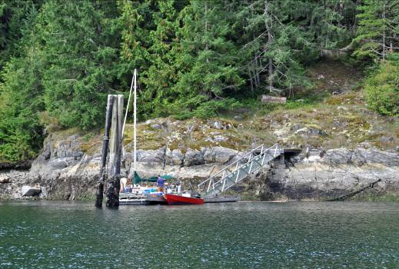
Recreational boaters in Whiterock Passage

Stop 9
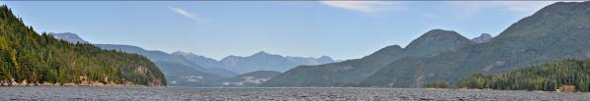
East entrance of Whiterock Passage viewing north, logging on Stuart Island is easy to see despite the viewing distance. This is the only visual impact in otherwise natural appearing landscape.

Stop 10
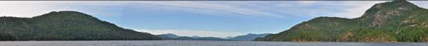
Okisollo Channel viewing north, natural appearing scene, conforming well to R & PR VQOs.
Stop 11
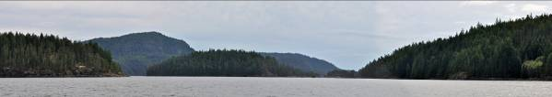
Surge Narrows Provincial Park, natural landscape.

Stop 12
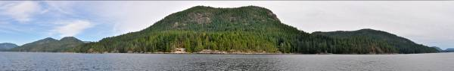
Okisollo Channel viewing Maurelle Island. BCTS log dump visible along the foreshore. A small industrial intrusion to otherwise natural appearing landscape. Conforming to the Partial Retention VQO.

Stop 13
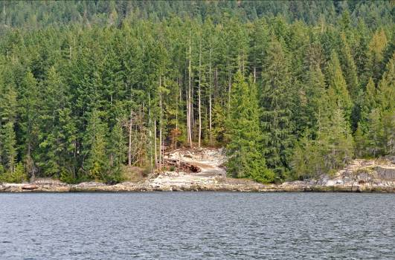
Close-up view of BCTS Log dump, Maurelle Island viewed from Okisollo Channel. Designed to limit the negative visual impact. See also Stops 116 and 117.
Stop 14

Sonora Island, viewed from mid Hole in Wall. A natural appearing landscape which is conforming to the Retention VQOs.

Stop 15
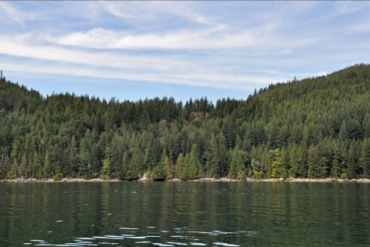
Sonora Island, Hole in Wall, Block 11360 (TimberWest) designed to be non-visible, conforming to Retention VQO.

Stop 16
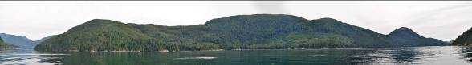
Hole in Wall passage viewing (south) to Maurelle Island. Old cutblock now greened-up and conforming to the Partial Retention VQO.
Stop 17
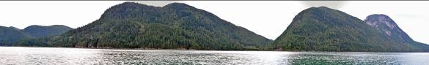
Sonora Island seen from Calm Passage. TimberWest Block 11-360 remains non-visible. Conforming well to Partial Retention VQO.

Stop 18
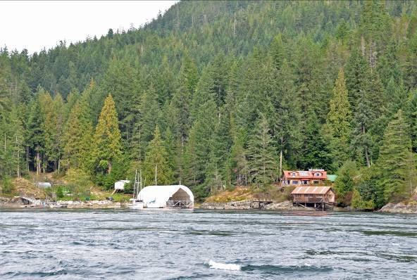
Diamond Bay, Sonora Island (Ross Campbell home).

Stop 19
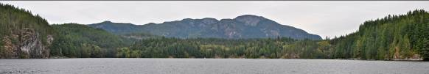
Owen Bay panoramic view of Sonora Island. Largely natural appearing. Conforming to Retention and PR VQOs.

Stop 20
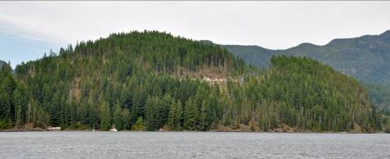
Owen Bay, Sonora Island, visible cutblock conforming to the PR VQO.

Stop 21
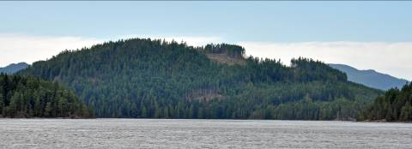
Sonora Island, north of Owen Bay, TFL 47 Block 11-33H conforming to PR VQO. Cutblocks are easy to see, appear small in relative scale, and not rectilinear or angular.

Stop 22
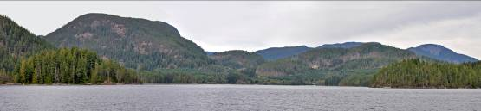
Barnes Bay, Sonora Island, harvesting of various ages making landscape appear somewhat tattered, conforming to PR VQO.
Stop 23
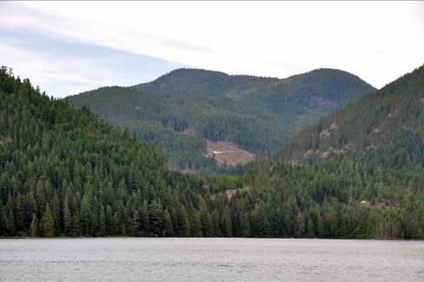
Sonora Island east of Woods Bay. A passing view to boaters. A relatively small and rounded appearing cutblock & road conforming to the Partial Retention VQO.

Stop 24
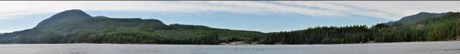
Sonora Island, Woods Bay. A largely natural setting with exception of log dump. Conforming well to the Partial Retention VQOs.

Stop 25
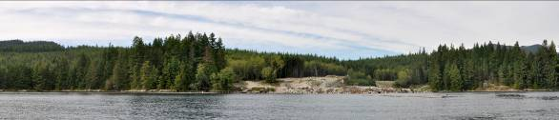
Sonora Island. Close-up view of Woods Bay log dump. An industrial setting that is not conforming to the spirit & intent of Partial Retention. Exposed rock & soil is visually significant. Visual rehabilitation would soften the negative visually impact.
Stop 26
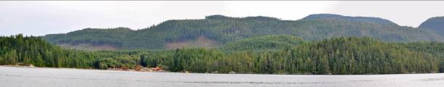
Quadra Island, Okisollo Channel east of Chonet Bay log dump. Overall the harvesting is conforming to PR VQO. However, the cutblock seen in the center is verging towards Modification visual quality class due to slight angularity of cutblock.
Stop 27
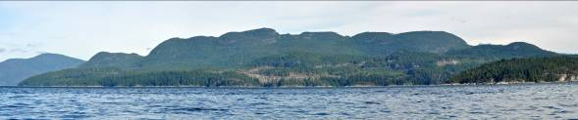
Western Sonora Island viewed from Johnstone Strait, south of Elk Bay. TFL 47 Block 11-406 is conforming to the PR VQO. In-block tree retention aids in reducing the apparent scale and negative visual impact.

Stop 28
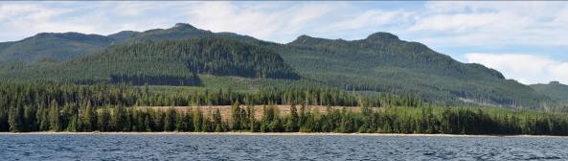
Elk Bay, Vancouver Island. Block Elk 171 is conforming to PR VQO when viewed from center channel of Johnstone Strait. It is verging towards a Modification visual quality class due to straight appearing back boundary. Foreshore reserve is minimal to protect from potential windthrow damage. Old harvesting pattern is showing strong unnatural angularity.
Stop 29
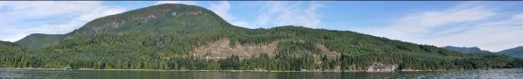
Sonora Island viewed from Okisollo Channel, near Venture Point. Conforming to PR VQO but verging towards a Modification visual quality class due to somewhat blocky shape. Right side of cutblock has effective level of in-block tree retention.

Stop 30
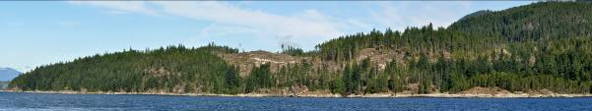
Sonora Island, west entrance to Okisollo Channel near Granite Point. TFL 47 Block 11-406 is very easy to see foreground harvesting. It appears large in scale relative to small landform. The clearcut contrasts in colour & texture to the surrounding forest. It interrupts the skyline and includes some visually obvious road cut. It has merged slightly into a Modification visual quality class and therefore is not conforming to the PR VQO.

Stop 31
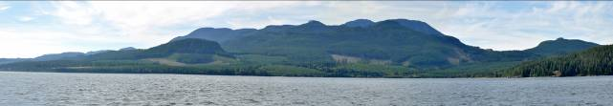
Elk Bay, Vancouver Island. Interfor Block ELK-194 (center of photo) is easy to see, medium in scale, with some straight unnatural lines. Viewed from a typical boating distance, the harvesting patterns conform to the PR VQOs. However, the unnatural appearing straight boundary line of Block Elk-194 is verging on achieving a Modification visual quality class.
Stop 32
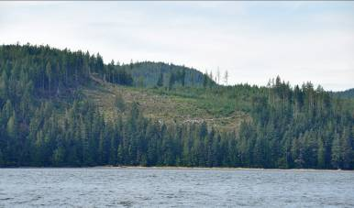
Elk Bay, Vancouver Island, Interfor Block ELK-191, small block, no obvious angularity, when viewed from midground distance (typically of recreational boat traffic) it conforms to the PR VQO.

Stop 33
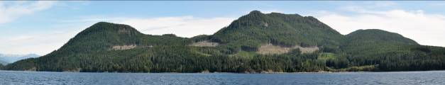
Sonora Is., Green Sea Bay, BCTS harvesting. Cutblocks are very easy to see, high contrast in colour & texture, medium in relative scale of landform alteration. Various openings do not show strong angular characteristics. Harvesting is conforming to PR VQO but is beginning to merge towards achieving a Modification VQC.

Stop 34
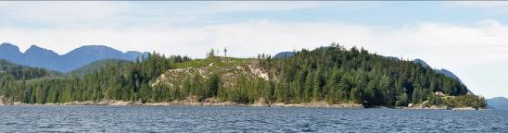
Chatham Point, privateland logging. Original visual impact is beginning to lessen with visual green-up.
Stop 35
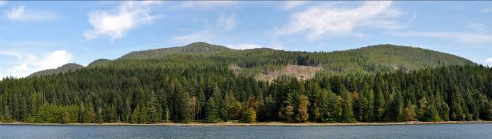
Sonora Island, Kumealeon Bay, TFL 47 Block 11-68. Harvesting shows good visual design and the in-block tree retention helps to mitigate the negative visual impact. Conforming well to the Partial Retention VQO.

Stop 36
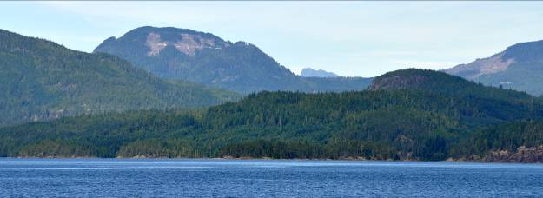
Hemming Bay, TFL 47. Harvesting is easy to see, focal position high on landform, unnatural visual design, some angularity and visible road cuts. The resulting visual impact has slipped into a Modification visual quality class and is not conforming to the PR VQO.
Stop 37
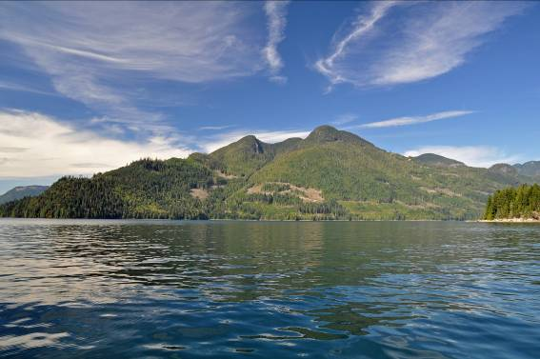
Fredrick Arm near Hall Point, from a distant view the harvesting is conforming to PR VQO.

Stop 38
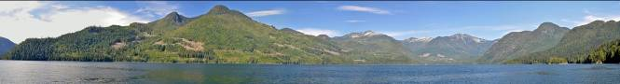
Frederick Arm near Hall Point. Individually the cutblocks conform to the PR VQO. In combination the landscape is trending towards a Modification visual quality class and pushing the boundaries of acceptable visual change. Future harvesting needs to consider adjacent green-up and careful aesthetic design to reduce the cumulative visual impacts.
Stop 39
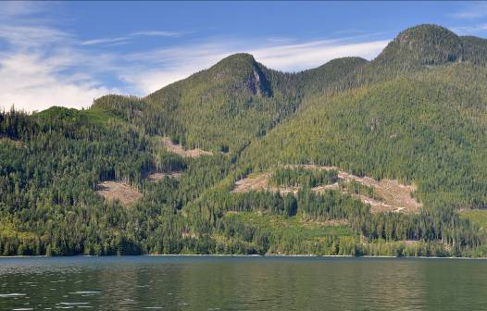
Frederick Arm. From shorter viewing distances the harvesting is verging towards Modification visual quality class. Block on right showing an overall rectilinear shape. The amount and pattern of in-block tree retention is insufficient to mitigate the visual impact. Cutblocks seen on the left demonstrate well-designed natural shape, pattern and size.

Stop 40
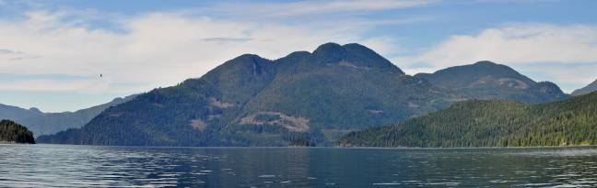
Frederick Arm seen at distance from Denham Bay, Cordero Channel. Harvesting is conforming to PR VQO but is verging on Modification visual quality class.
Stop 41
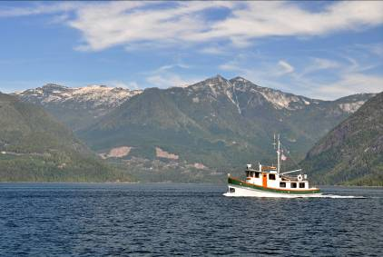
Head of Frederick Arm (TFL 45), viewed from Cordero Channel. (telephoto). Small to medium appearing blocks relative to large coastal landform. Blocks appearing extremely angular with high contrast in colour & texture. Viewed from within Frederick Arm the harvesting appears as a Modification visual quality class and therefore not conforming to the PR VQO. See also the close-up view taken from Stop 42 below.

Stop 42
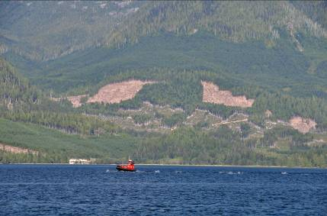
Whale watching boat in Frederick Arm (taken with telephoto lens). Showing 2 strongly contrasting harvest blocks with angular unnatural boundary shapes.
Stop 43
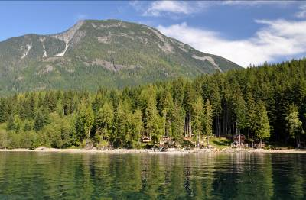
Denham Bay Resort, Cordero Channel. One of the few vacation resorts within the Discovery Islands. In addition to channel view locations, resorts are considered significant public viewpoints.

Stop 44
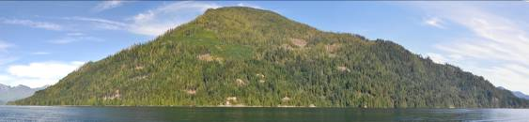
Phillips Arm at Cordero Channel. Small heli blocks are well design and distributed with minimal visual impact. Conforming to PR VQO.

Stop 45
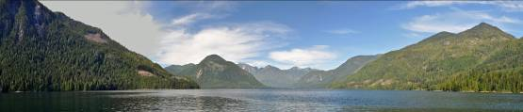
Midway into Phillips Arm. Viewing to head of Inlet. The extent of primary viewpoints, conforming to the Partial Retention VQOs.
Stop 46
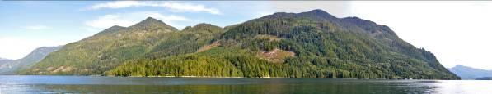
South side of Phillips Arm in Cordero Channel, TFL 45, relatively medium sized appearing cutblocks . No obvious angular characteristics. Conforming to the Partial Retention VQOs.

Stop 47
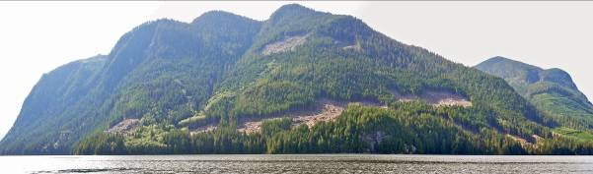
North side of Phillips Arm (confluence with Cordero Channel), TFL 45, very easy to see, medium to large appearing size, some angularity, and contrasting orientation across the landform, resulting in Modification visual quality class, not conforming to the PR VQO.

Stop 48
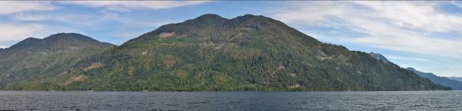
Phillips Arm south side viewed from Cordero Channel, TFL 45, a variety of new and historical logging, conforming to the Partial Retention VQOs.
Stop 49
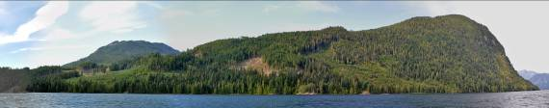
Cordero Channel near Picton Point, small well-designed cutblock, large older cutblocks have achieved visually effective greened-up, overall conforming to the PR VQO.

Stop 50
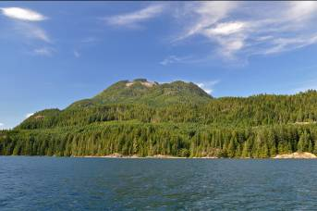
Cordero Channel at Brooks Bay. Moderate sized cutblock has interrupted the visually sensitive ridgeline. Despite the focal position when viewed from a distance the harvesting is still conforming to the PR VQO.

Stop 51
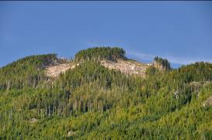
Telephoto view of ridgetop harvesting (as above). Although cutblock is relatively small the interruption of the skyline is resulting in a significant visual impact.

Stop 52
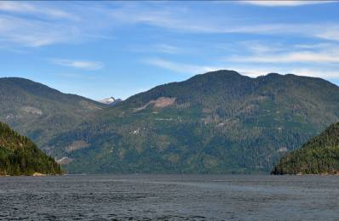
Phillips Arm (telephoto) TFL 45 seen from Cordero Channel. The landscape is showing a pattern of various age types resulting from forest harvesting. Overall, the landscape is in conformance to the PR VQO. The most recent harvest block is exhibiting some angular qualities and lack of aesthetic design.

Stop 53
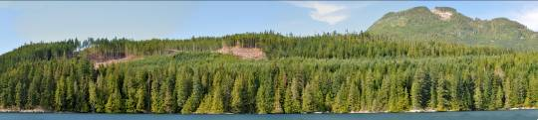
Near Cordero Lodge. Harvesting design and in-block tree retention aid in limiting visual impact. Conforming to the Partial Retention VQO.
Stop 54
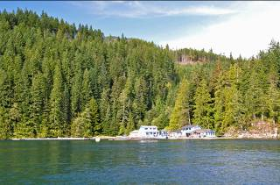
Cordero Lodge. Care appears to have been taken to ensure harvesting is not seen from the lodge, TFL 47.

Stop 55
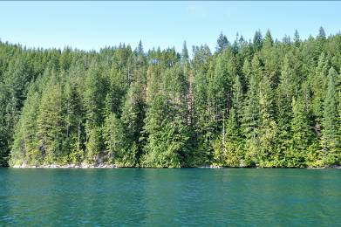
Near Cordero Lodge. Foreshore leavestrip (commercial thin) maintained to ensure harvesting is not apparent. TFL 47.

Stop 56
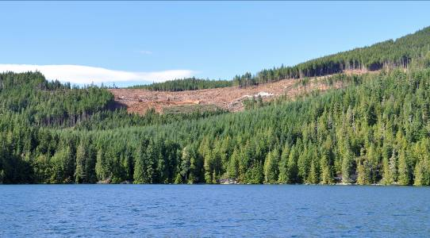
Cordero Channel (mainland) west of Green Point. Relatively good visual design. However, the fresh logging in the foreground has significant visual impact due to temporary high contrast in colour in texture. Viewed from mid-channel locations the harvesting conforms to the PR VQO.
Stop 57
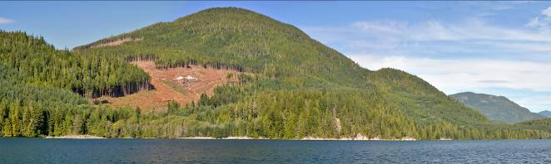
Cordero Channel north of Cordero Lodge. TFL 47 Block 7-058. Clearcut is very easy to see in the foreground. Medium in scale relative to landform. No strong angular characteristics. Transition between PR and Modification visual quality class. Borderline conformance to PR VQO.

Stop 58
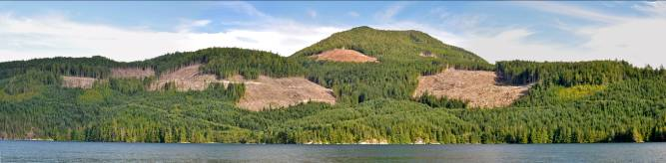
Longhborough Inlet, TFL 47. Clearcut harvesting is very easy to see in the foreground. Medium in scale with some straight boundaries and strongly angular characteristics. No evidence of any aesthetic design considerations. Conforming to the Modification VQO.
Stop 59
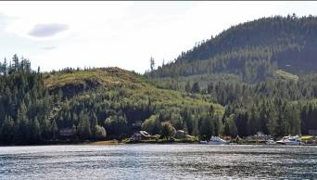
Blind Channel Resort on West Thurlow Island. The visual impact of old privateland loggings is beginning to soften with green-up of forest vegetation.

Stop 60
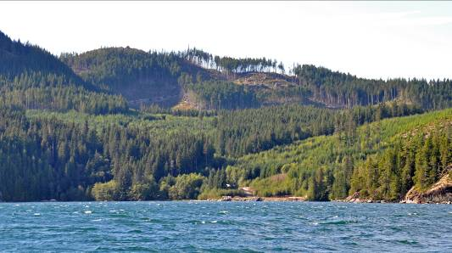
West Thurlow Island, TFL 45. Harvesting showing visual design problems. Cutblock upper left is blocky with dominant road cut. Ridgeline tree retention is insufficient to prevent a “picket fence” effect. In combination the harvesting is conforming to PR VQO. However it is verging on achieving a Modification visual quality class.

Stop 61
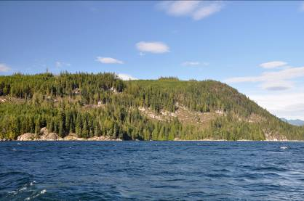
West Thurlow Island, Butterfly Bay, TFL 45. Conforming to the Partial Retention VQO. Irregular shaped openings that are interspersed with in-block tree retention patches assist in meeting the VQO. Cutblock at the time of harvest would have verged on a Modification visual quality class.
Stop 62
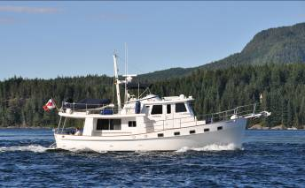
Yacht cruising by East Thurlow Island

Stop 63
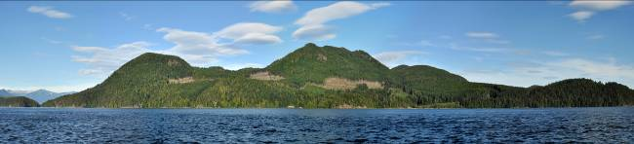
Sonora Island, Green Sea Bay, BCTS Block K034C2FA, easy to see and medium is scale. Somewhat blocky, angular and unnatural shaped openings. Conforming to the Partial Retention VQO but is borderline Modification.

Stop 64
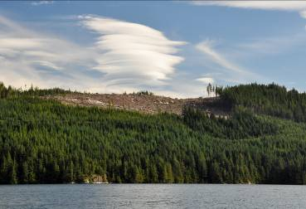
Lougborough Inlet. Minimal visible debris and subordinate appearing road building. Ridgeline clear of scattered residual trees. Conforming to the Modification VQO.

(Stops 65-130 are primarily within the Sunshine Coast District)

Stop 65
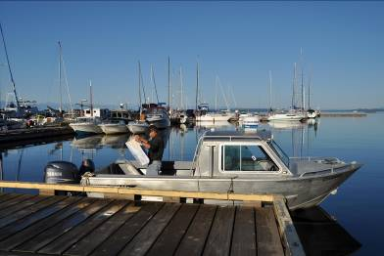
MFLNRO vessel “Sand Skipper”, Lund, BC

Stop 66
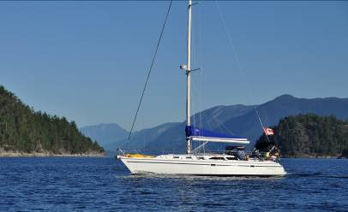
North of Lund near Kinghorn Island. Recreational boating traffic is provincially significant in the vicinity of Desolation Sound.
Stop 67
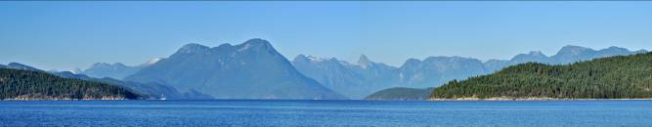
Sarah Point in Malaspina Channel. Scenically attractive and visually intact viewscape.

Stop 68
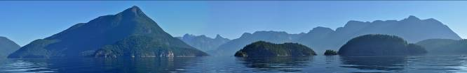
Desolation Sound near Homfray Channel. Visually intact viewscape. Internationally recognized scenic landscapes.

Stop 69
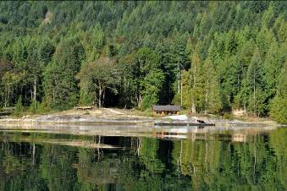
Cabin on shores of East Redonda Island.

Stop 70
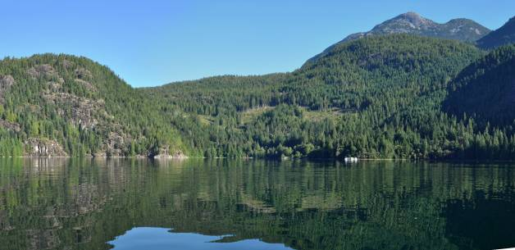
Atwood Bay. BCTS cutblock. Visually well designed harvesting showing natural shapes and in-block tree retention. Good example of conformance to PR VQO.

Stop 71
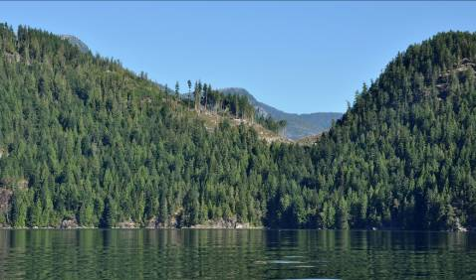
BCTS harvest block located at Brettel Point in Homfray Channel. Subordinate to the viewing experience and conforming to the PR VQO.
Stop 72
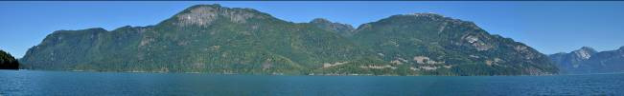
Interfor harvesting, mouth of Toba Inlet, near Brettel Point. Primarily natural shapes which are conforming to the PR VQO. Cumulative impact is verging towards Modification visual quality class.
Stop 73
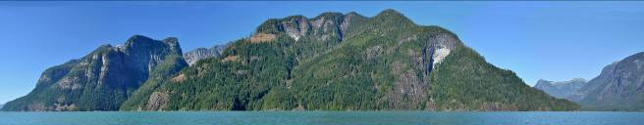
Extremely scenic landform in Toba Inlet showing some small dispersed helicopter logging. Good conformance to the PR VQO.
Stop 74
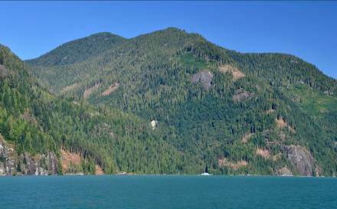
Toba Inlet west of Brem River. Small helicopter harvest blocks that are well shaped and distributed across the landform. Good example of conformance to PR VQO.
Stop 75
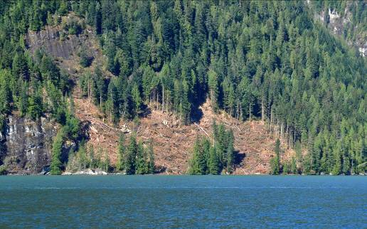
Telephoto view of Toba Inlet small heli block. Good visual design and conformance to PR VQO. Foreshore tree reserves could be more substantial to ensure they remain windfirm.

Stop 76
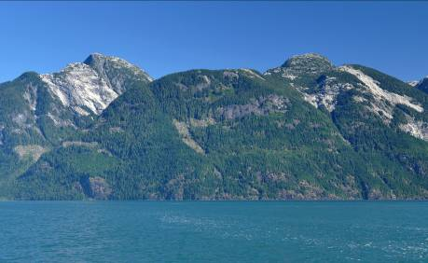
Toba Inlet heli block showing odd angular shape. Small in relative scale of landform alteration and conforming to the PR VQO. The poor visual design is verging towards Modification visual quality class.

Stop 77
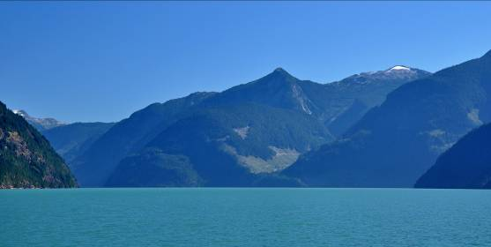
Toba Inlet outside legal scenic area (no VQOs). Exhibiting unnatural appearing visual design.

Stop 78
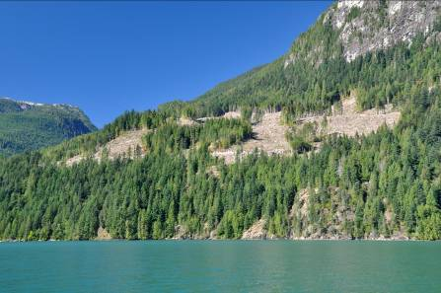
Toba Inlet , Brettel Point, VSU #211. Ground-based harvest conforming to the PR VQO. Overall “blocky” shape is reduced by in-block tree retention.
Stop 79
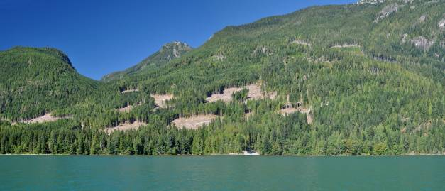
Mouth of Toba Inlet, VSU #512, north of Brettel Point. A very good example of visual design helping meet the PR VQO. Cutblock/leave pattern and shape beneficial. High contrast in colour is temporary.
Stop 80
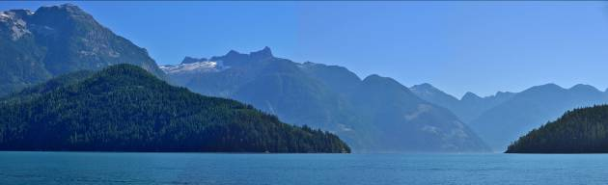
Confluence of Toba Inlet-Homfray Channel. Distant harvesting showing a lack of visual design.
Stop 81
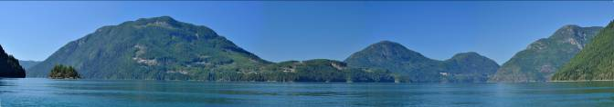
Eastside of Raza Island. Varied block shapes and sizes conforming to the Partial Retention VQO.
Stop 82
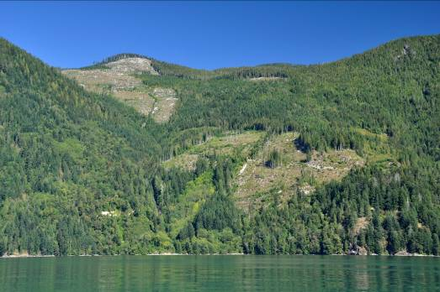
Pryce Channel mid-channel view location. At time of original harvesting it had a significant negative visual impact. C&E Investigation found this harvesting in non-compliance to the Partial Retention VQO. Province’s first VQO non-compliance and fine. November 2009.
Stop 83
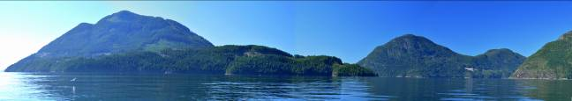Raza Island seen from Pryce Channel. A variety of forest harvesting conforming to the PR VQO. (Similar view as Stop 81).
Stop 84
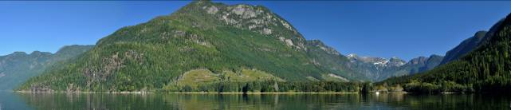
Ramsay Arm-Quatum River. Old harvesting greening-up and now conforming to the PR VQO. Initially the harvesting created a borderline Modification existing visual condition. Due largely to the cutblock’s relative scale of landform alteration, visual apparency, and simplicity of visual design.
Stop 85
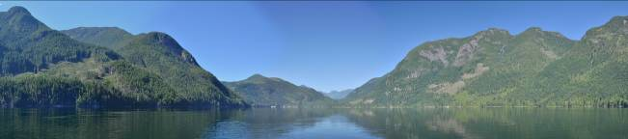
Head of Ramsay Arm. From this distance the harvesting conforms to the PR VQOs. To a degree the cutblocks reflect the natural patterns found in the exposed rock faces.

Stop 86
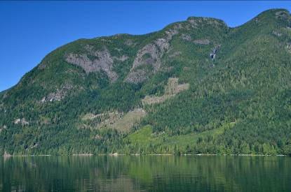
Head of Ramsay Arm, VSU 146. From a closer viewing distance this forest harvesting has slipped into a Modification visual quality class. Scale of landform alteration may be appropriate. However, its angular characteristics, apparency and lack of visual design is not conforming to the Partial Retention VQO legal definition.
Stop 87
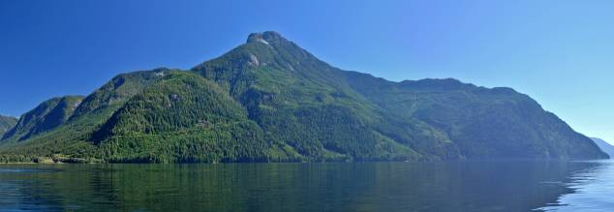
Ramsay Arm. Old forest harvesting has long reached visually effective green-up. Original harvesting pre-dates VQOs.

Stop 88
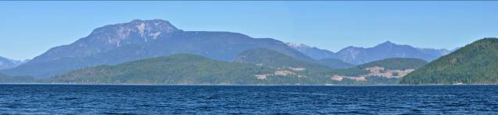
Stuart Island distant view. (Conformance opinion pending, currently under C&E investigation).

Stop 89
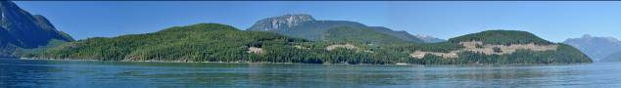
Stuart Island seen from Johnstone Bluff. (Conformance opinion pending, currently under C&E investigation).
Stop 90
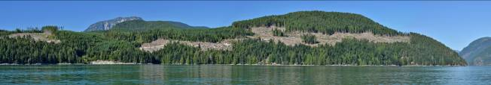
Stuart Island mid channel viewpoint. For boaters the harvesting is very easy to see and appears large in scale of landform alteration. (Conformance opinion pending, currently under C&E investigation).

Stop 91
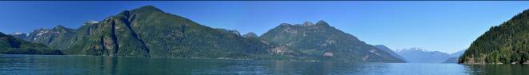
Bute Inlet panorama near Fawn Point. Distant logging conforms to the Partial Retention VQOs.

Stop 92
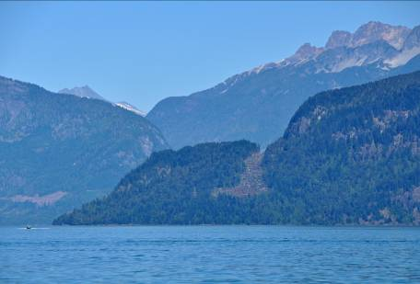
Bute Inlet near Fawn Point. Although conforming to the PR VQO the cutblock exhibits poor visual design. Visual notch along the focal ridgeline creates an abrupt edge that attracts viewers attention.
Stop 93
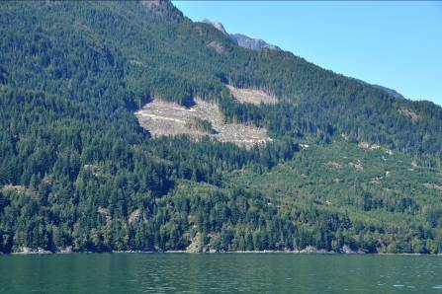
Bute Inlet VSU 85. Relatively small cutblocks with a significant negative visual impact due to poor angular design. Conforming to the Modification VQO.

Stop 94
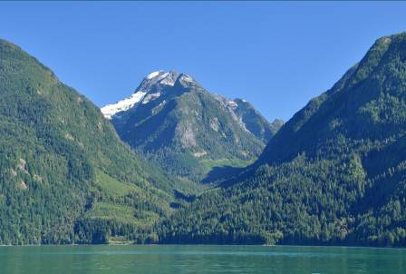
Bute Inlet scenic hanging valley. Old harvest cutblocks while discernible have reached visually effective green-up. Original harvest blocks appeared large and very rectilinear. Future forest harvesting shape, size, and pattern need to better consider visual design.
Stop 95
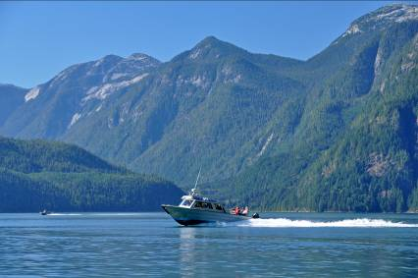
Bute Inlet, wildlife/scenic viewing charter boats.

Stop 96
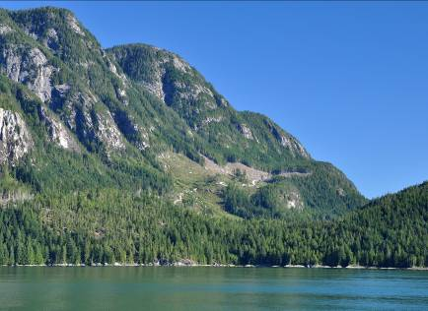
Mouth of Bute Inlet. Combination of harvest openings conforming to Partial Retention VQO. Contrasting cutblock colour and visual design borderlines on Modification visual quality class. Illustrates the importance of allowing sufficient visually effective green-up between adjacent harvest blocks.
Stop 97
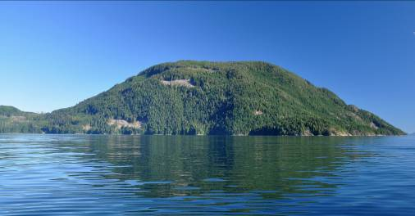
Raza Island. Relatively small appearing harvest openings conforming to the Partial Retention VQO. Lack of visual design and angular block shapes verging towards a Modification visual quality class.

Stop 98
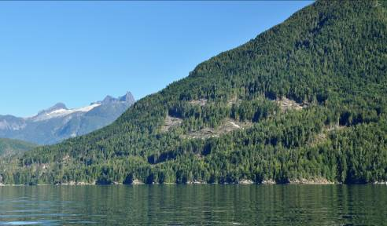
East Redonda Island. Radial pattern of in-block tree retention assists with conformance to the Partial Retention VQO.
Stop 99
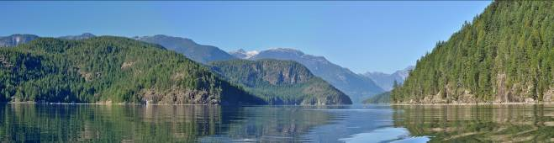
Waddington Channel viewing north. Largely natural appearing landscape.

Stop 100
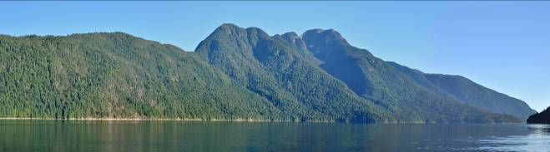
Pendrell Sound, East Redonda Provincial Marine Park, natural viewscape.

Stop 101
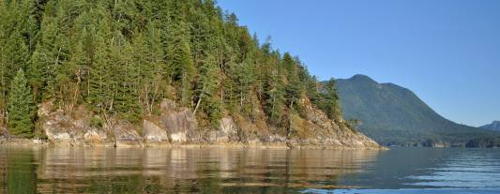
East Redonda Island, Horace Head. Scenic point of land with natural appearing landscapes.
Stop 102
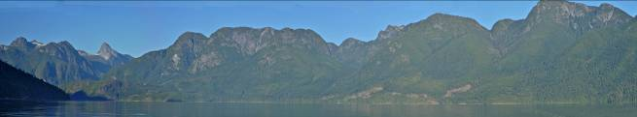
Homfray Channel, eastside, just north of Desolation Sound Marine Park. Some forest harvesting concentrated on lower slopes. Conforming to the Partial Retention VQO. FREP Sample DSC 2013-11.

Stop 103
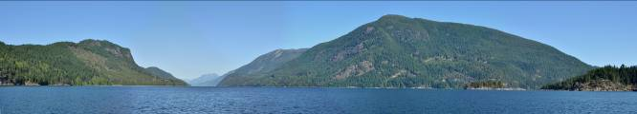
Lewis Channel viewing north near confluence with Teakerne Arm. Forest harvesting is quite subordinate and conforming to the PR VQOs. Older privateland harvesting cutblocks have visually softened with forest green-up and are now conforming to the Partial Retention VQO. (left side of photo).

Stop 104
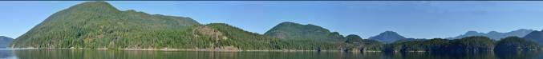
Mid Teakerne Arm panorama. Viewing north to West Redonda Island. Natural appearing landscape that conforms to the Retention VQOs.
Stop 105
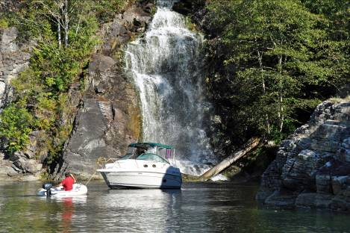
Teakerne Arm Provincial Marine Park. Popular destination for recreational boaters.

Stop 106
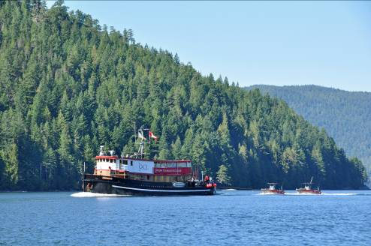
Queen Charlotte Lodge tug (sport fishing charters) returning from Haida Gwaii. Lewis Channel. Scenic viewing is recognized as an important component to sports fishing tourism.
Stop 107
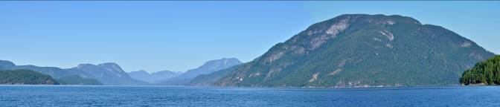
Top of Lewis Channel viewing north. Raza Island on right side. Largely natural appearing. No issues of conformance to Partial Retention VQOs.
Stop 108
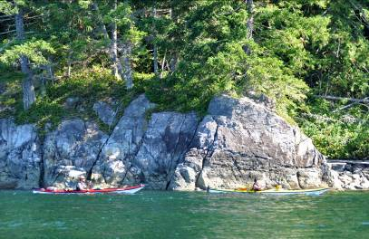
Ocean Kayakers in Deer Passage following the shoreline.
Stop 109
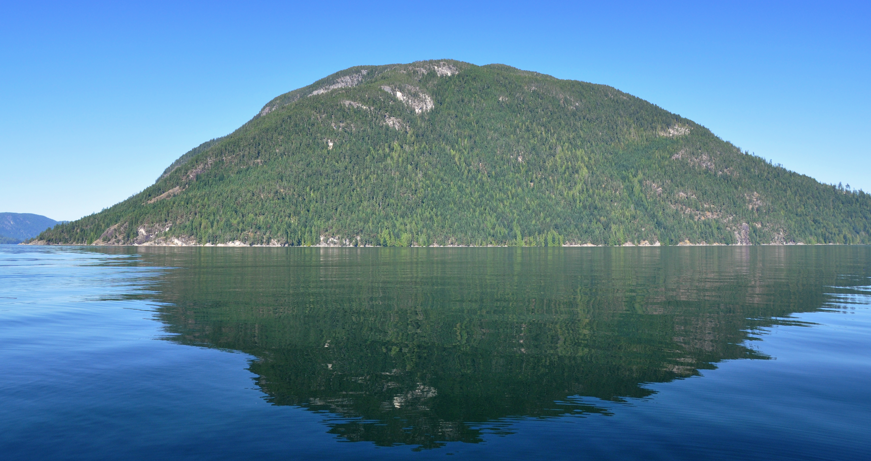
Raza Island viewed from Deer passage. Natural appearing landform at the southern end of the island.
Stop 110
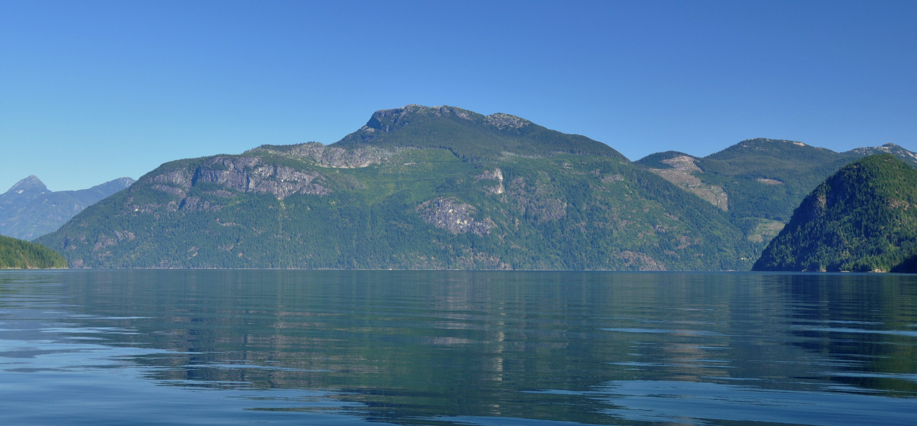
Deer Passage confluence with Pryce Channel. Evidence of old forest harvesting still discernible despite many years of green-up. More recent harvesting along Pryce Channel (right side of image) is clearly visible and showing unnatural shape and size.

Stop 111
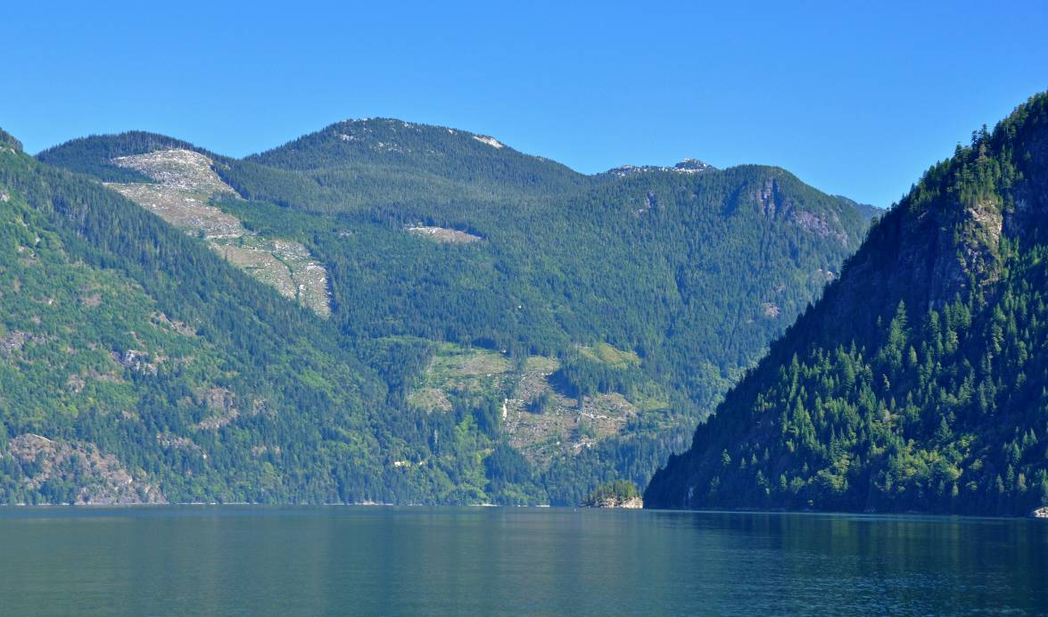
Deer Passage viewing into Pryce Channel. At time of harvest the blocks appeared to not conform to the Partial Retention VQO. C&E determination of non compliance.
Stop 112
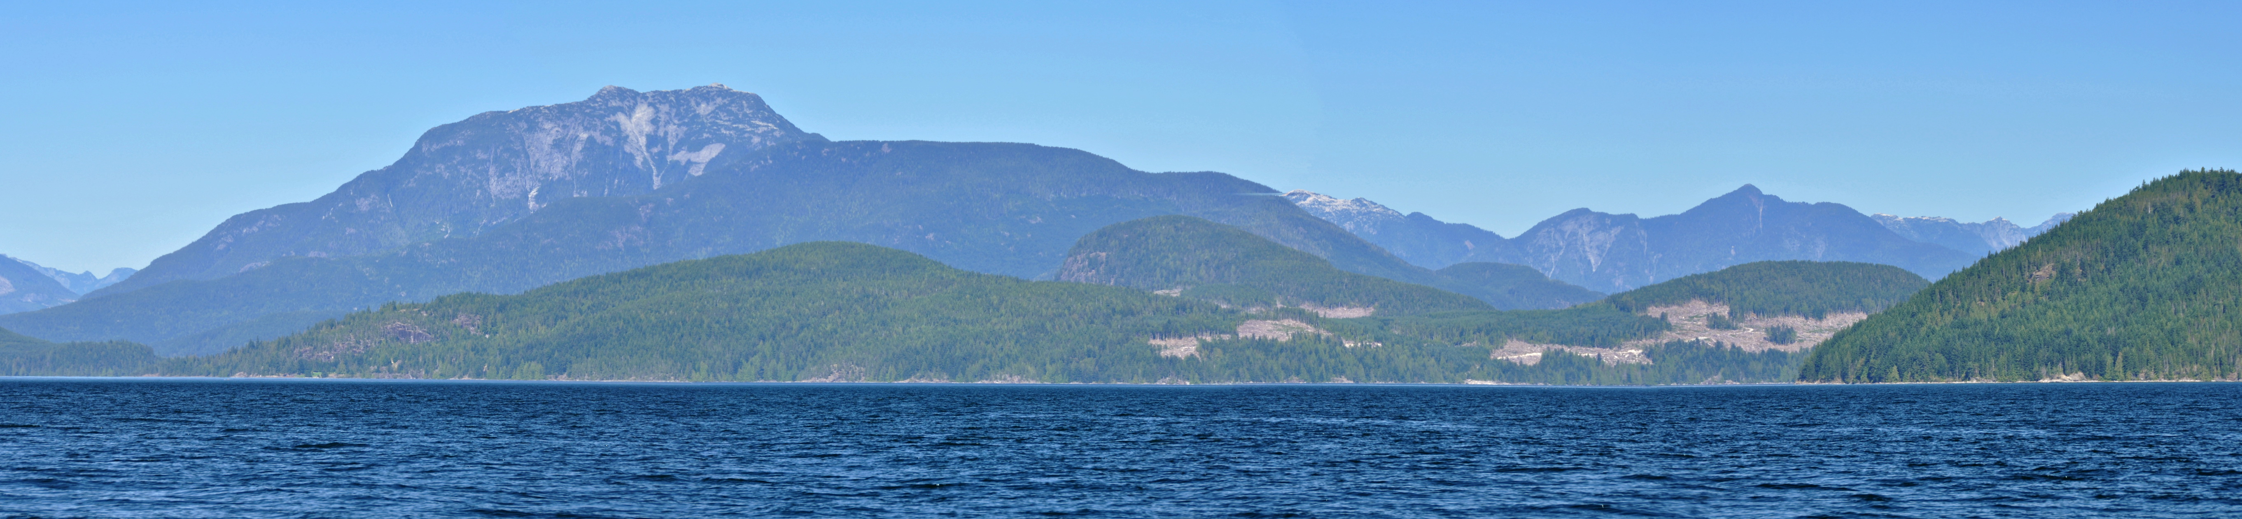
Distant view of forest harvesting on Stuart Island. Significant contrast caused by logging is very easy to see from long distances. Currently under C&E investigation for VQO compliance. See also Stops 88, 90, and 123.
Stop 113
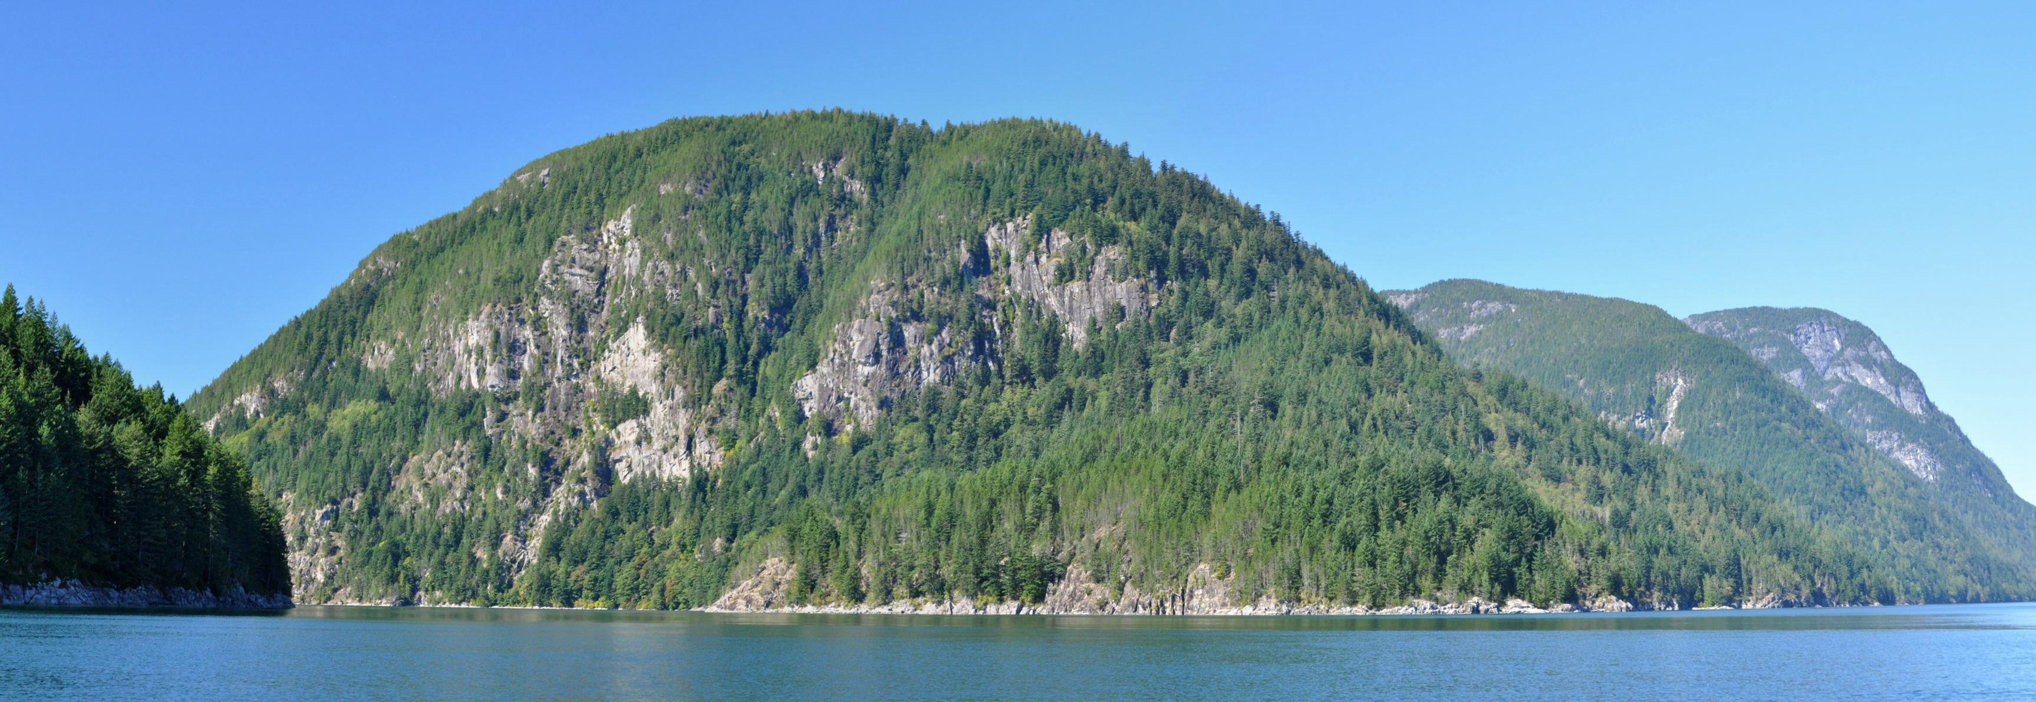
Eastern entrance to Hole-in-Wall passage. Natural appearing 2nd growth forest
. Stop 114
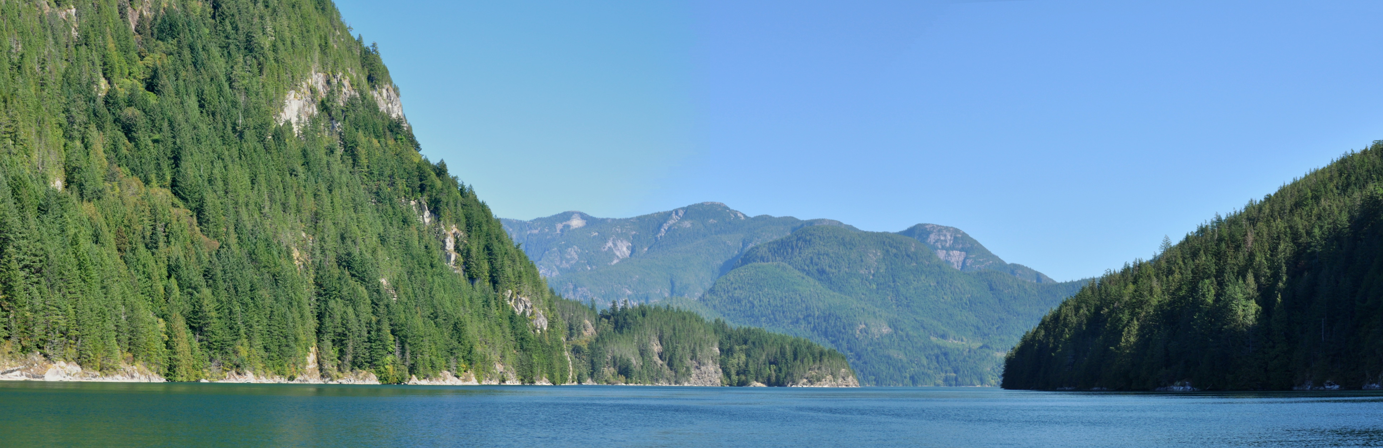
Eastern entrance into Hole in Wall passage (viewing west). Largely natural appearing landscape. No issues of conformance to the Retention and PR VQOs.
Stop 115
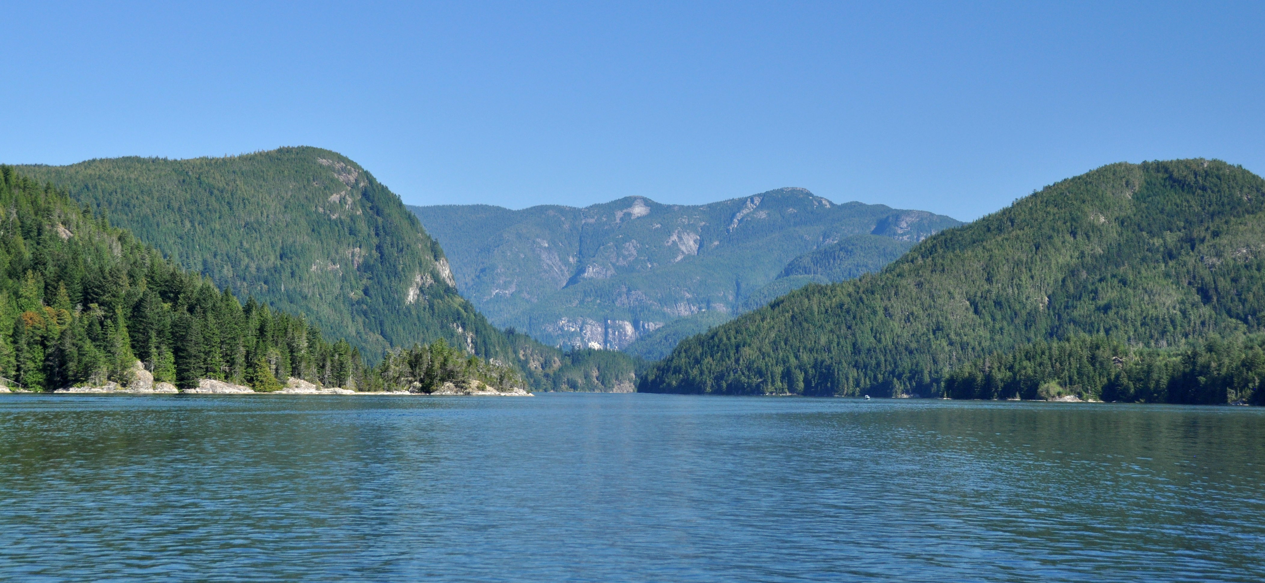
Western Entrance to Hole in Wall passage (viewing east). Older forest harvesting within the passage is not evident from this view location. No issues of conformance to the Retention and PR VQOs.

Stop 116
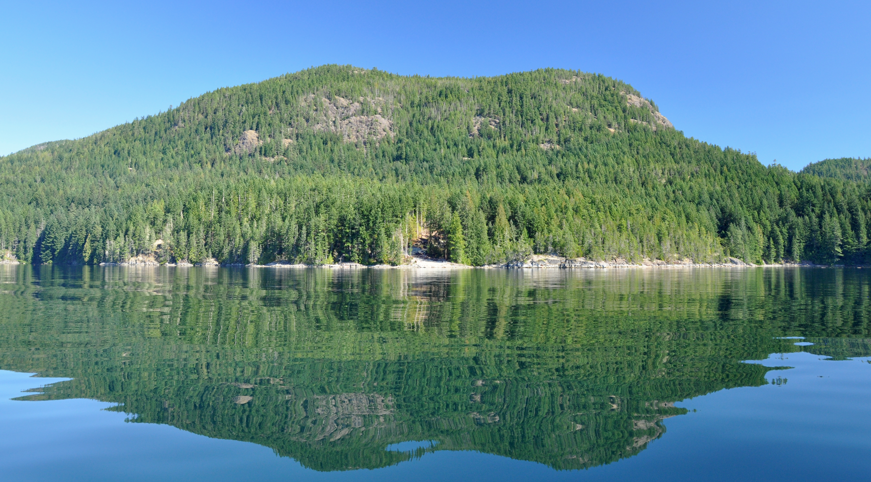
Maurelle Island, BCTS logdump is visible along the foreshore. From this mid-channel viewpoint the alteration appears small and visually subordinate. Meets the spirit and intent of the Partial Retention VQO.
Stop 117
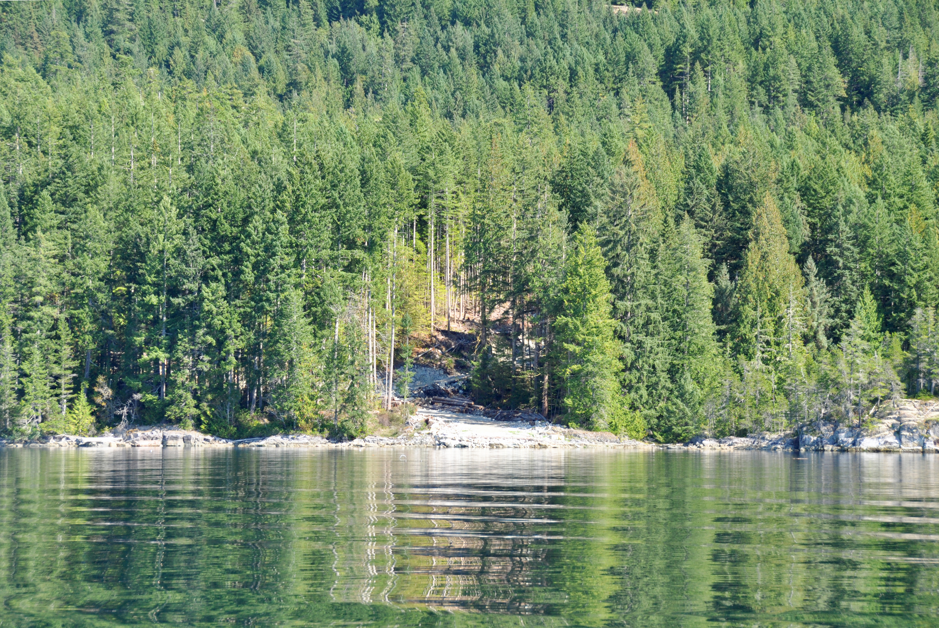
Telephoto view of BCTS logdump on Maurelle Island, Okisollo Channel. Relatively small industrial intrusion to a otherwise natural appearing landscape. Tree retention, narrow width and road layout has helped minimize the visual impact.

Stop 118
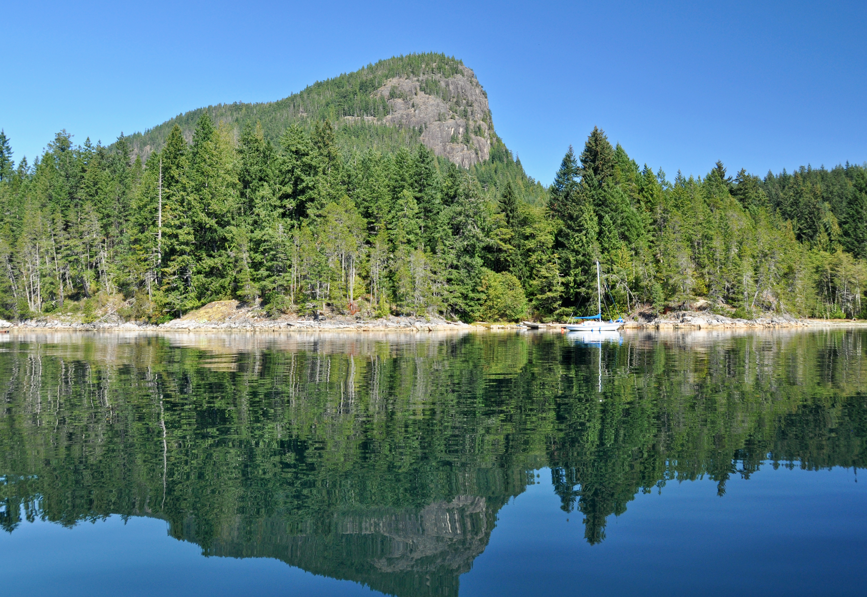
Maurelle Island seen from Okisollo Channel. Scenic view of natural appearing landscape.
Stop 119
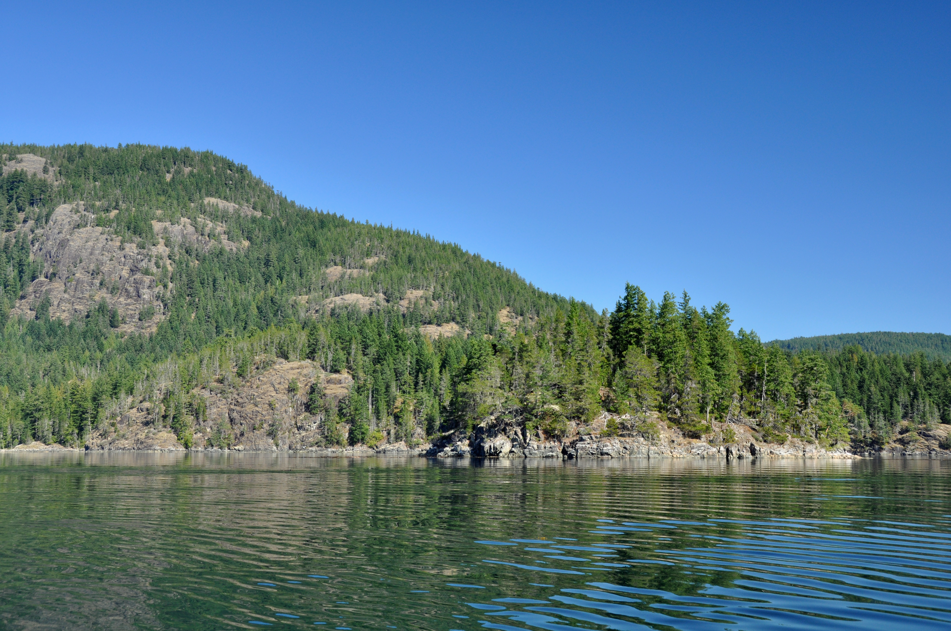
Maurelle Island seen from Okisollo Channel. Dry rocky slopes of predominantly 2nd growth Douglas Fir. No obvious signs of recent forest harvesting. No issues of VQO conformance to the PR VQOs.

Stop 120
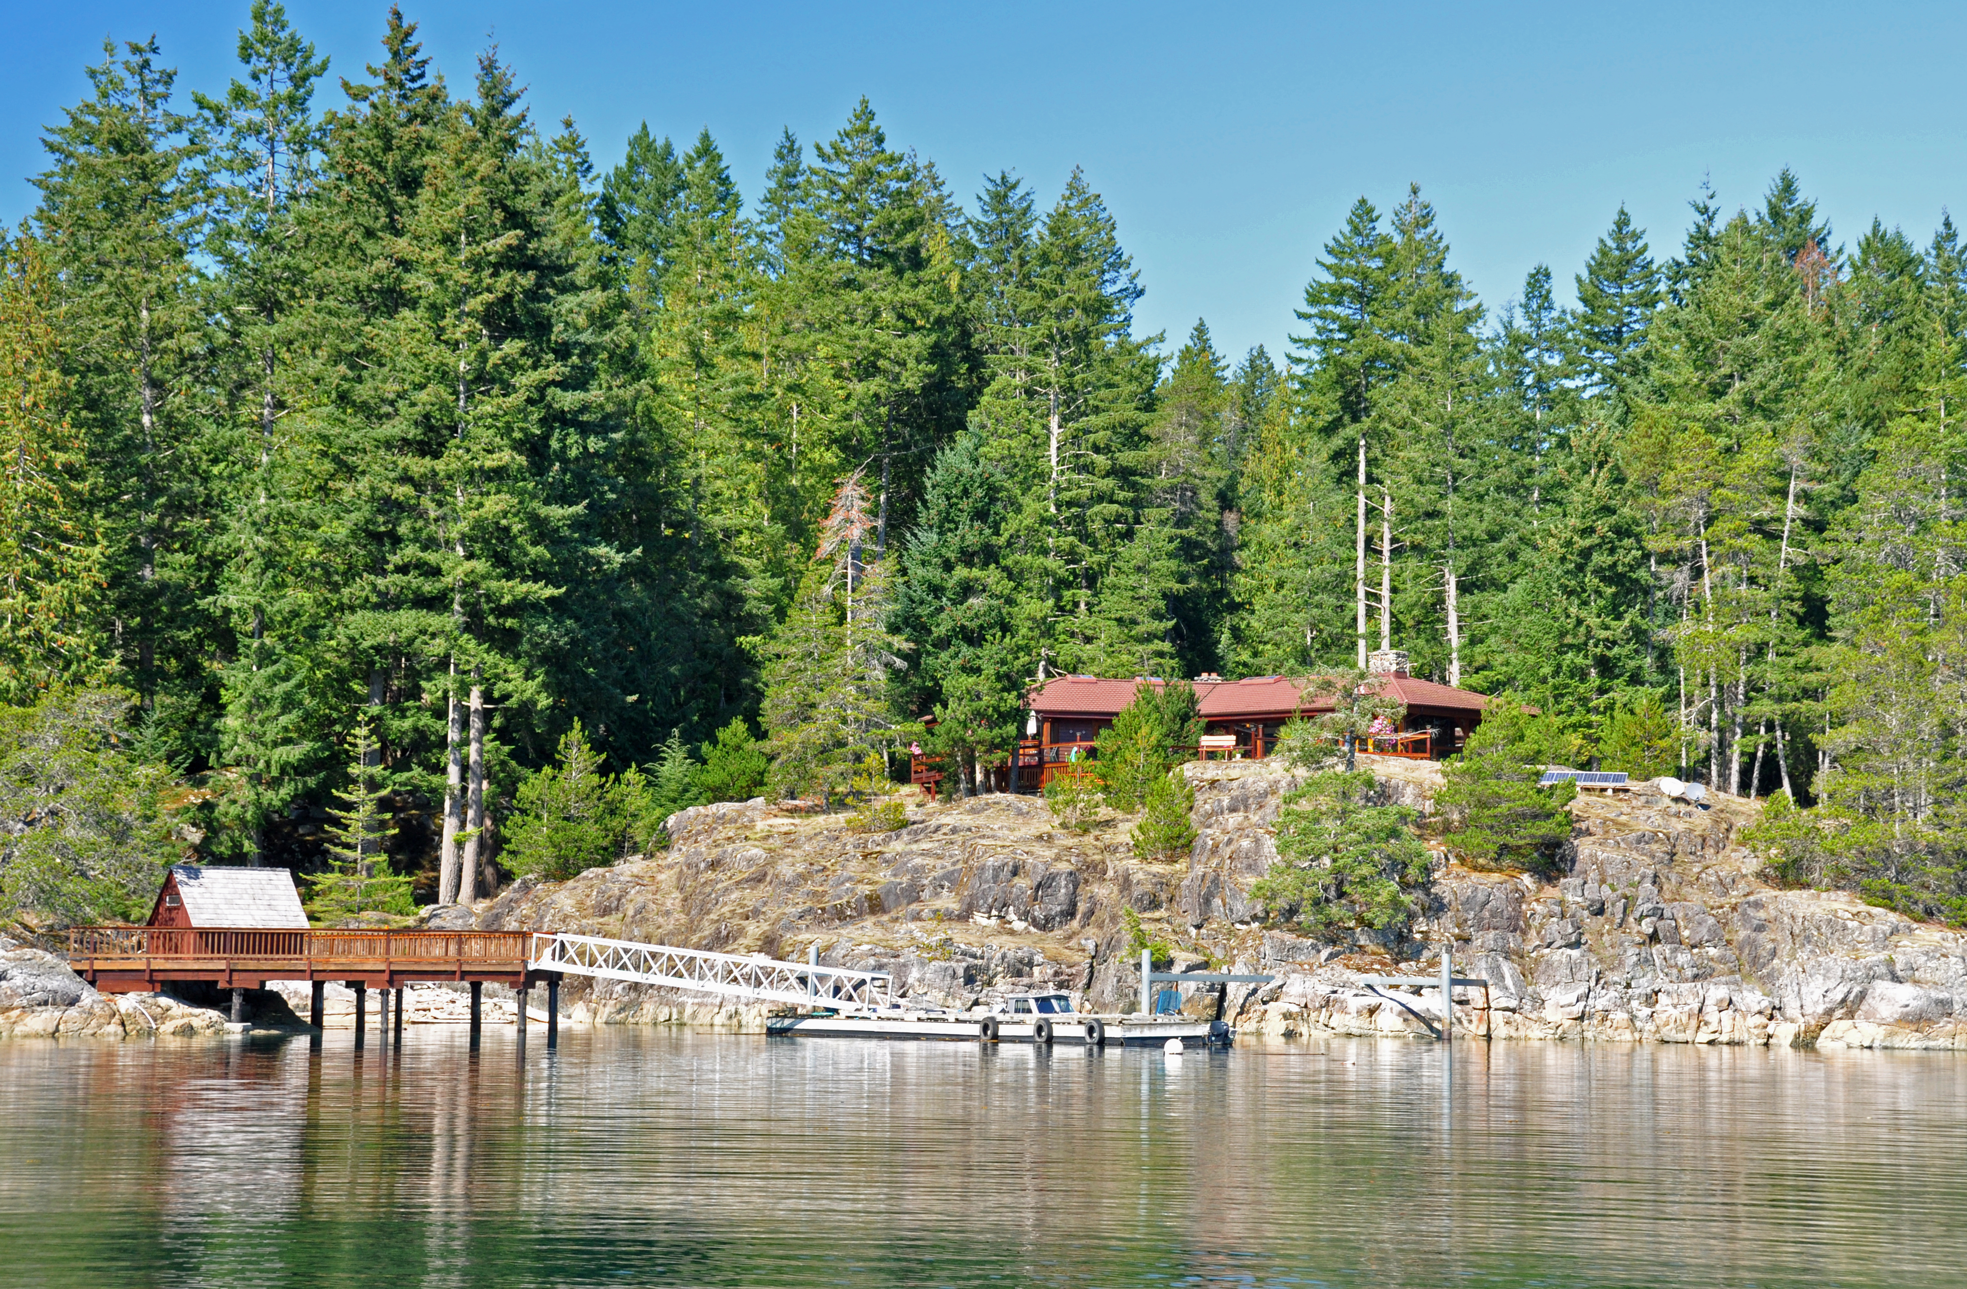
Read Island home. One of the residences that are scattered amongst the Discovery Islands. Visual management from permanent land-based homes can be a concern.
Stop 121
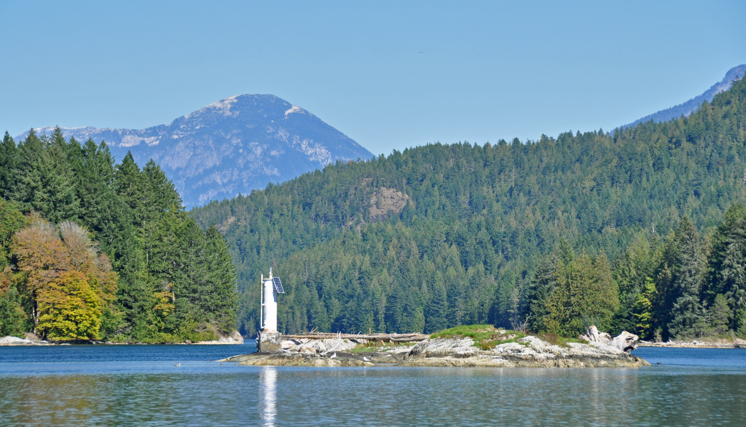
South entrance to Whiterock Passage. Natural appearing landforms. Discovery Islands is a visually interesting and complex mix of foreground, middleground, and background landforms. Visual management in each of the distance zones may require different strategies of visual management to ensure consistency with the VQOs.

Stop 122
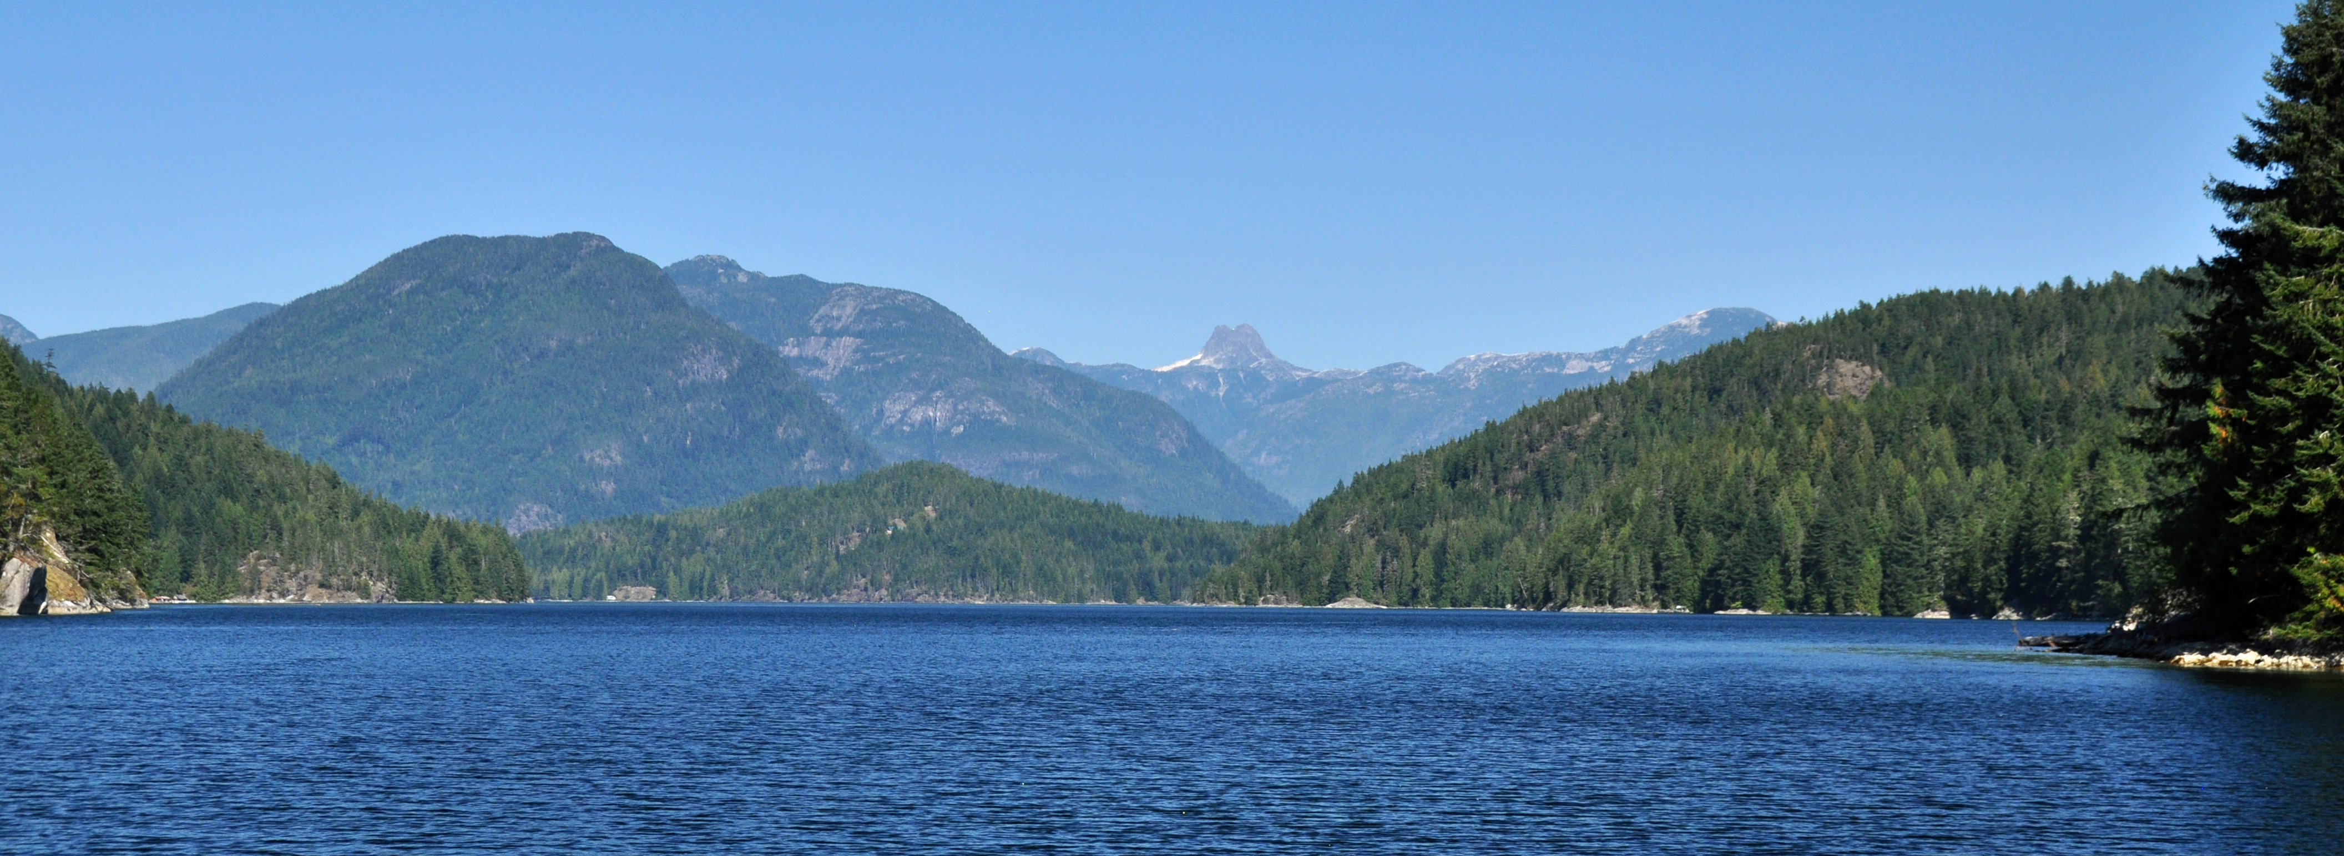
Whiterock Passage middle section (viewing east). A popular passage for small recreation boaters and kayakers. Natural appearing landscape. Conformance to the foreshore Retention VQOs.
Stop 123
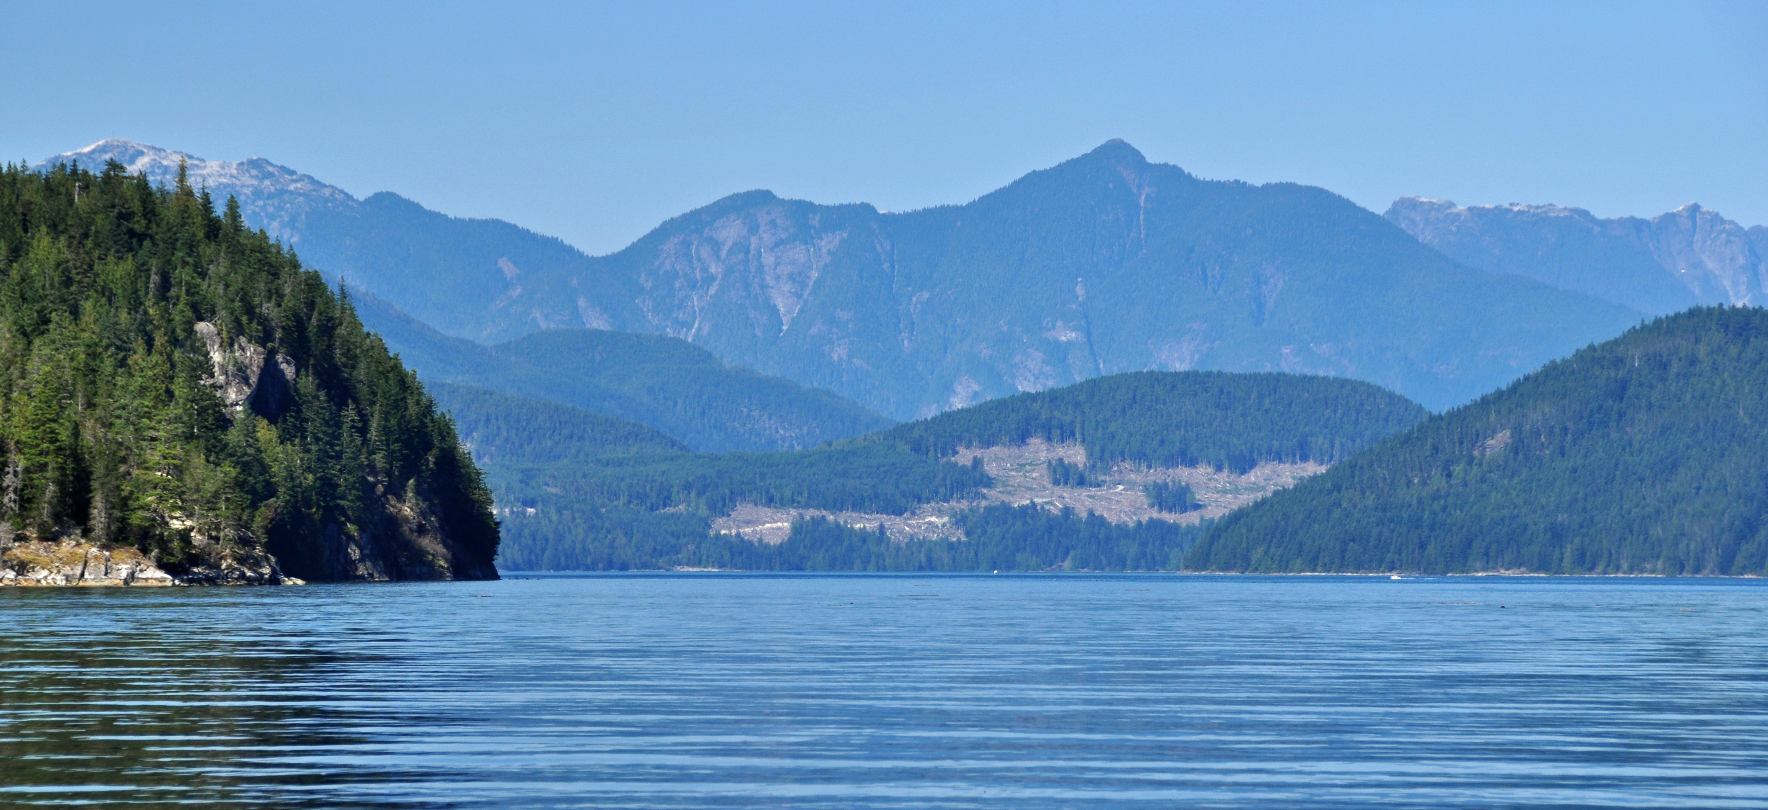
Top of Whiterock Passage, viewing north. Telephoto view towards forest harvesting on Stuart Island. Harvesting is very easy to see and exhibits some unnatural angular characteristics. Currently under C&E investigation for VQO compliance.

Stop 124
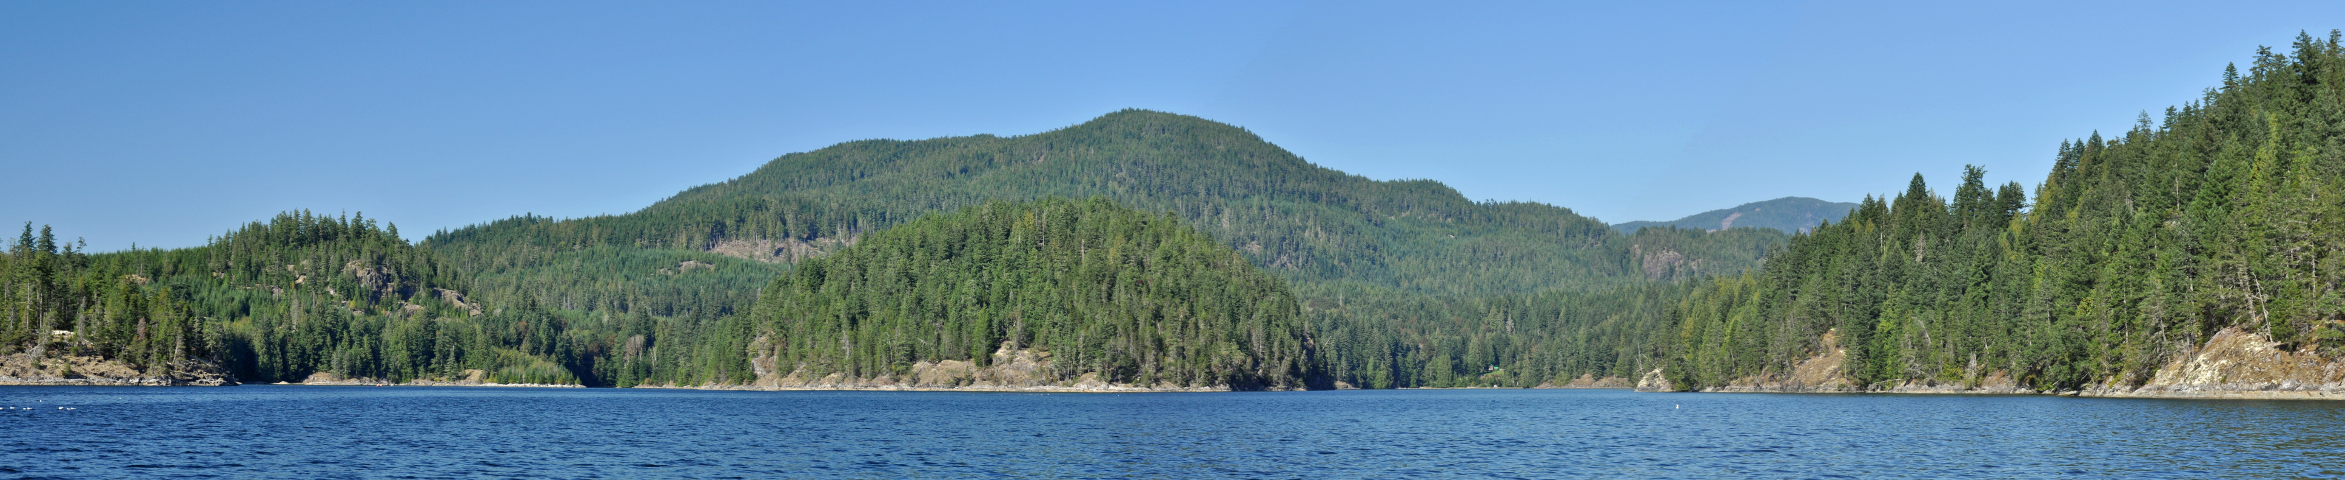
Evans Bay, Read Island (viewing NE). Small and naturally shaped cutblock remains somewhat difficult to see. Dispersed in-block tree retention assists with mitigating visual impact. Conforming to the Retention VQOs.
Stop 125
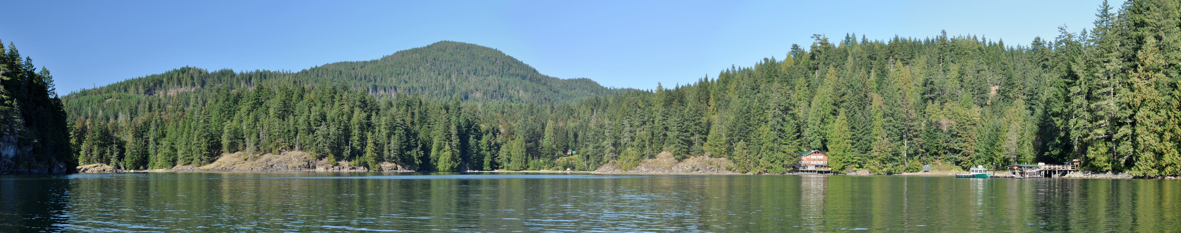
Head of Evans Bay panorama, Read Island. Forest harvesting remains very difficult to see. Conforming to the Retention VQO.
Stop 126
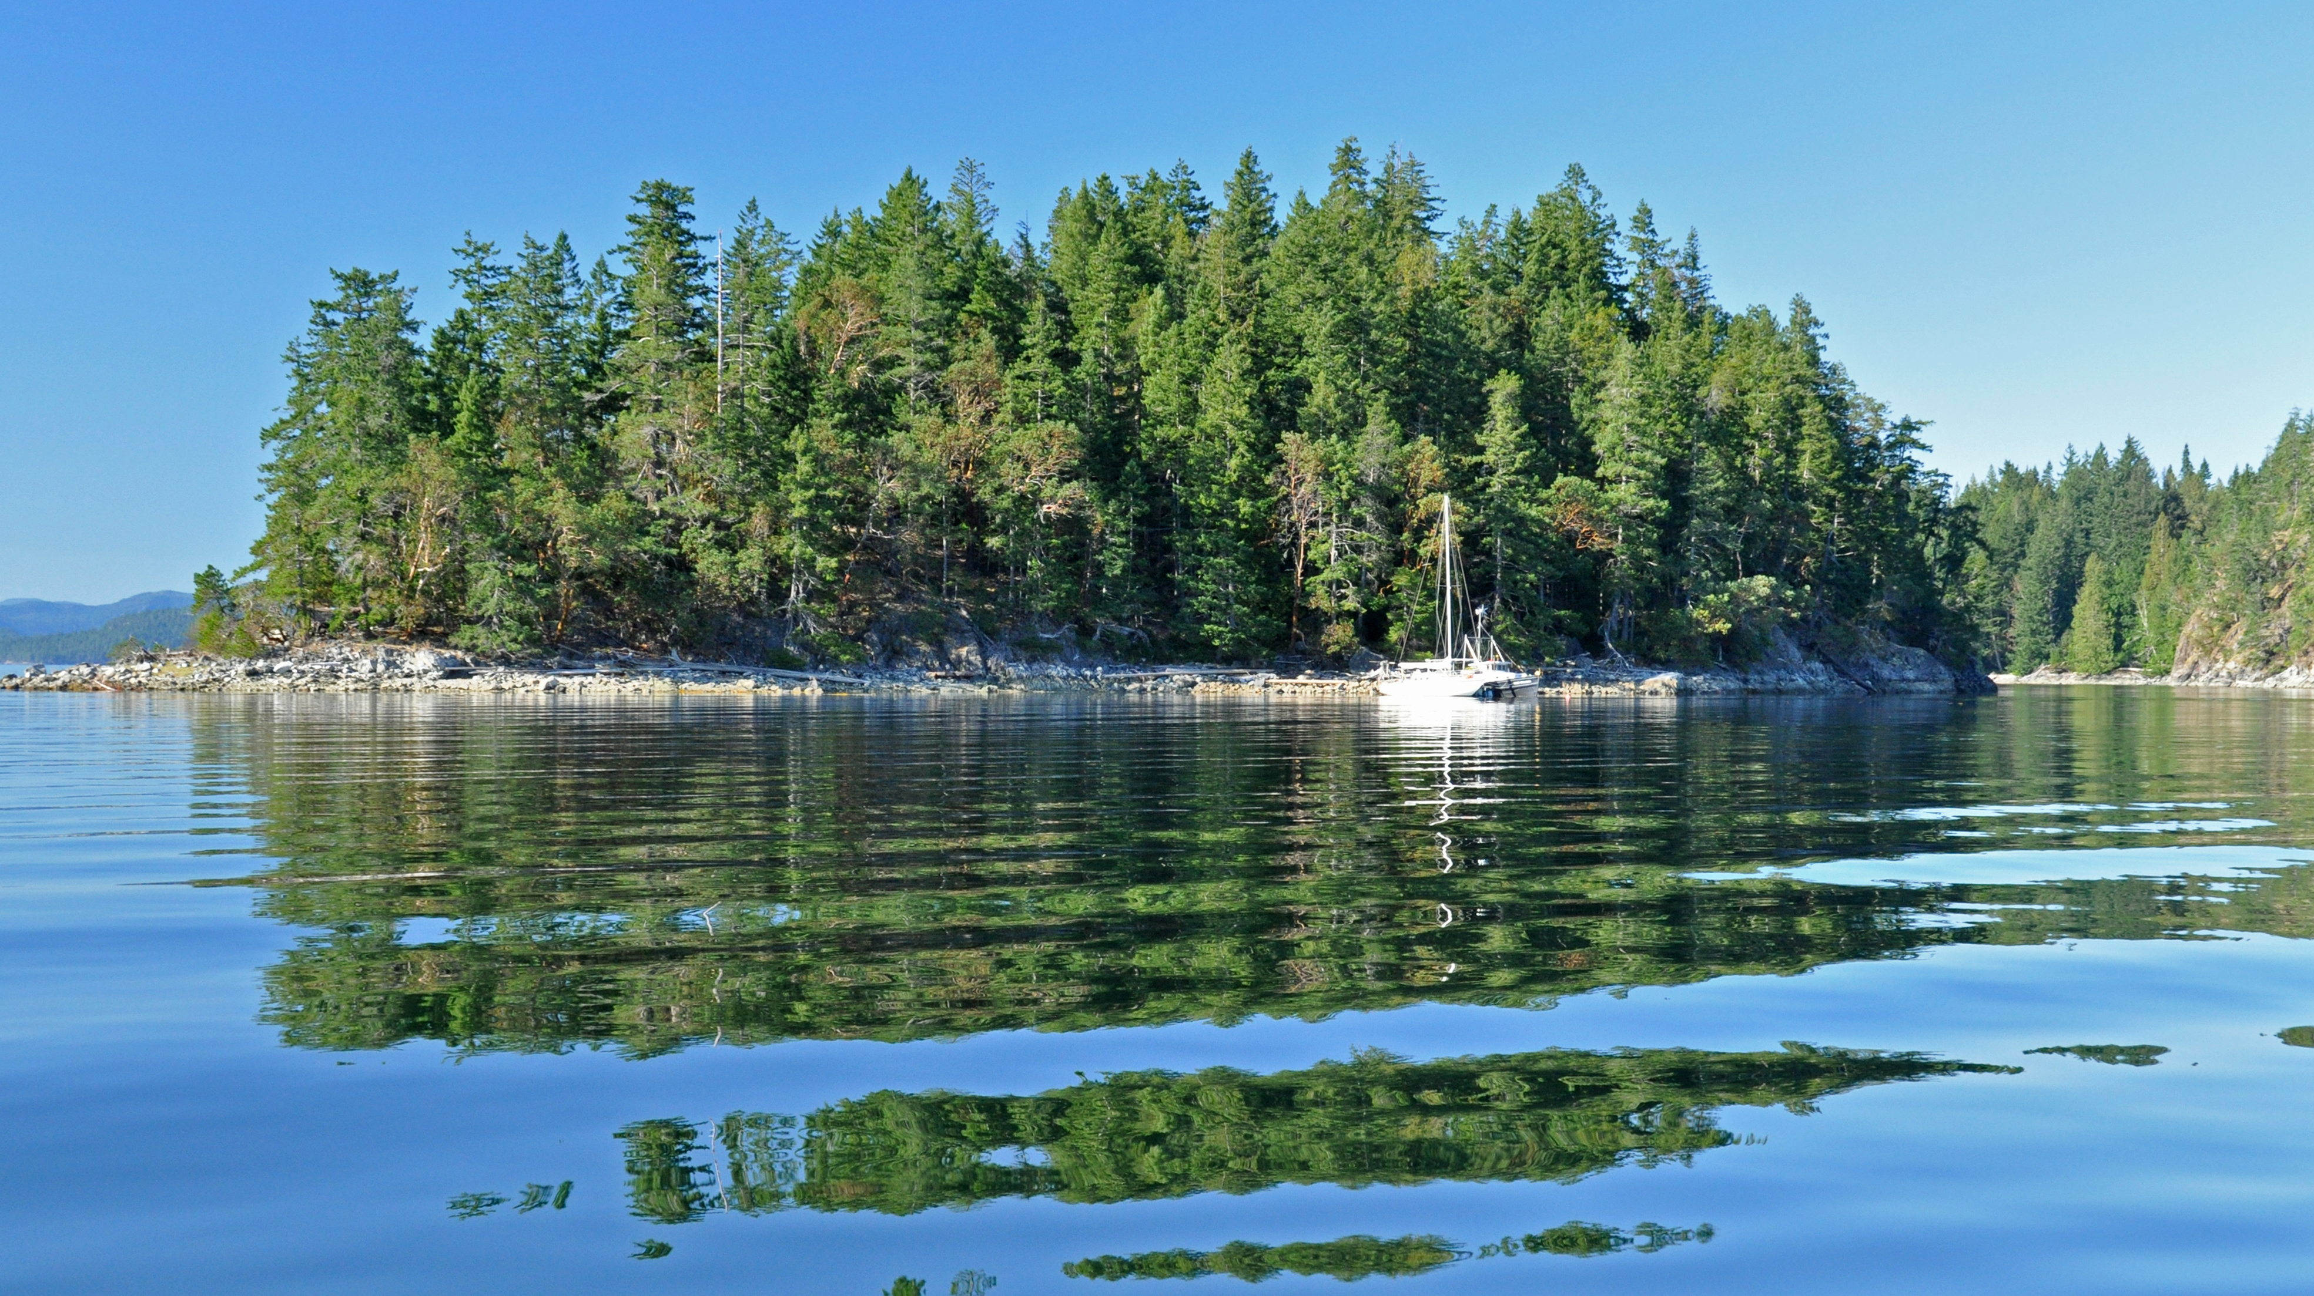
Carrington Bay, Cortez Island. Visually intact foreshore. Managing the foreground views from popular marine anchorages remains important. Employing special forest harvesting strategies in the land-water interface maybe required to meet the VQOs.

Stop 127
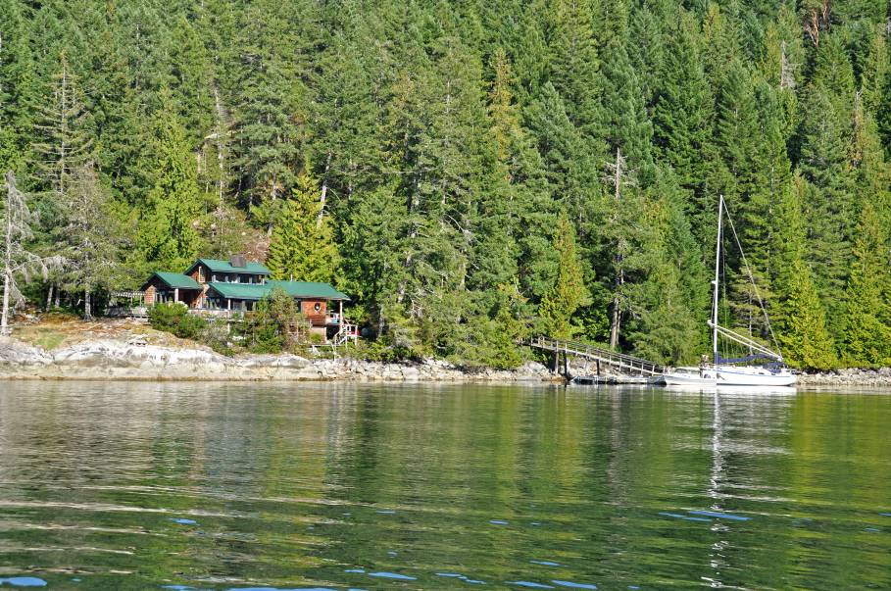
Quartz Bay, Cortez Island. Illustrative of the residential settlement pattern scattered around Cortez and southern Quadra Island.
Stop 128
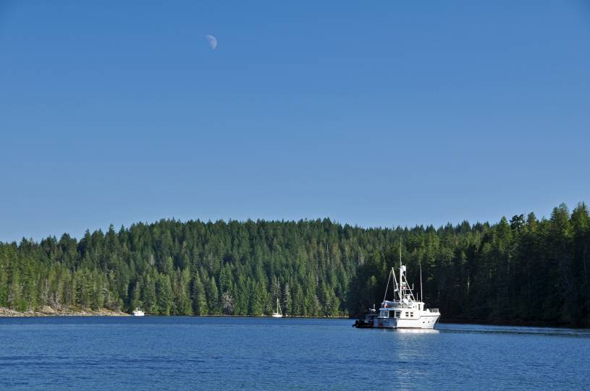
Von Donop Inlet Provincial Marine Park, Cortez Island. Conformance to the Preservation VQOs. Visual impact mitigation strategies are important in managing the views from the formal and popular anchorages dispersed throughout the Discovery Islands.

Stop 129
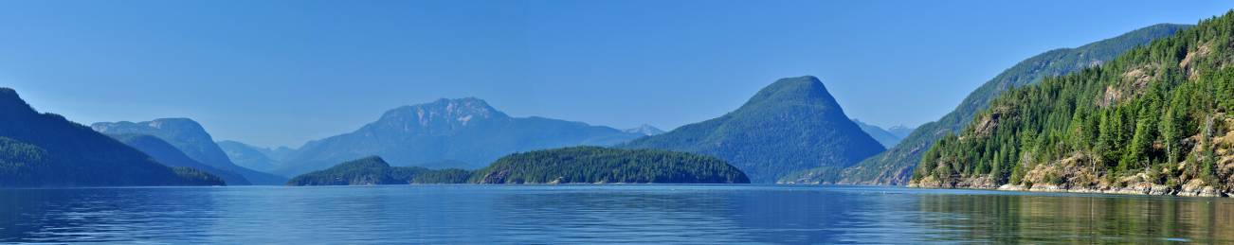
Top of Cortez Island viewing north. Natural appearing viewscape. Illustrative of the intact high quality scenery.
Stop 130
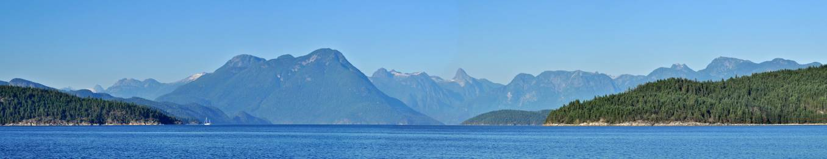
Sarah Point, northern tip of Malaspina Peninsula (12 km north of Lund, BC). Viewscape remains naturally appearing. Dramatic coastal scenery draws both domestic and US boaters to this part of the Province.
Summary
Overall the in-field review found the level of conformance to legally established Visual Quality Objectives within the Discovery Islands parallel the earlier findings completed under the FREP program. It has found the vast majority of forest harvesting and road building is conforming well to the VQOs. However, this review has found a significant number of situations of borderline conformance to the VQOs legal definition. Here the forest harvesting is verging towards non conformance. In these cases the visual impact is towards the maximum level of development for the VQO class. Lack of visual landscape design is largely responsible. In a few locations, the cumulative visual impact of forest harvesting is responsible. The report also documents a small (6) but significant number of non conformances to the VQO. In addition to the borderline cases, these non conformances are potential sources of negative public/stakeholder criticism. They may negatively affect local and visitor satisfaction which may have consequences for the tourism industry.

Recommendations
To ensure greater conformance to VQOs, forest licensees need to put more emphasis on visual landscape design. It is important that licensee staff practice with sufficient expertise in visual resource management. Foresters practicing in visually sensitive landscapes need to acquire and maintain sufficient education, training, and expertise in visual management. Alternatively, forest licensees should be employing qualified consultants. Licensees may need to consider a wider range of professional peer review of their forest development plans when operating in important scenic areas.
Licensees need to continue using robust visual impact assessment procedures. In addition, the cumulative visual impact on the landform and the greater landscape scene needs to be considered.
Licensees need to foster cooperative information sharing with potentially affected public/recreation/tourism stakeholders to help resolve visual management concerns. Digital (website) information sharing of pre-harvest visual impact assessments should be explored. For their part, the tourism sector needs to work cooperatively with the forest companies to resolve or accommodate their interests in maintaining scenic quality.

References

Visual Landscape Inventory, Procedures & Standards Manual,
Forest Practices Branch, Ministry of Forests, May 1997.

Visual Landscape Design Training Manual, Recreation Branch publication 1994:2,
Ministry of Forests, 1994.

Visual Impact Assessment Guidebook, Second Edition, Forest Practices Code of British Columbia, Ministry of Forests, January 2001.

Appendix 1
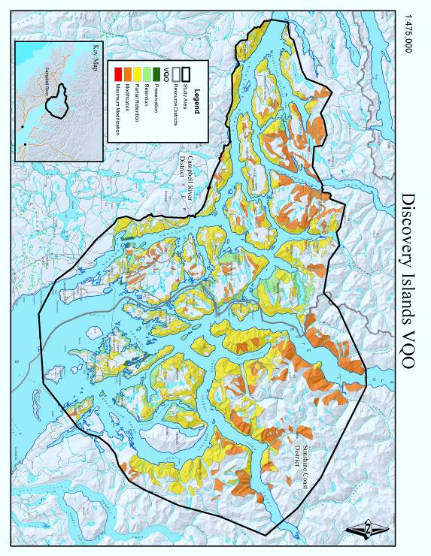
Appendix 2 Route Map
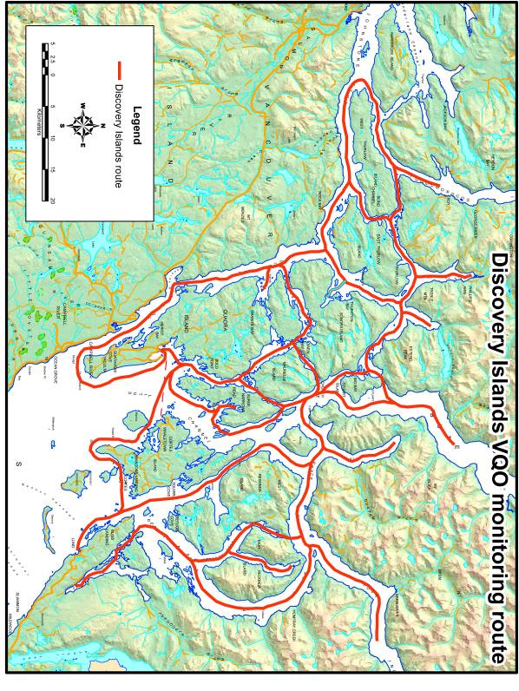
Appendix 3 Map of Photographic Stops 1 thru 130
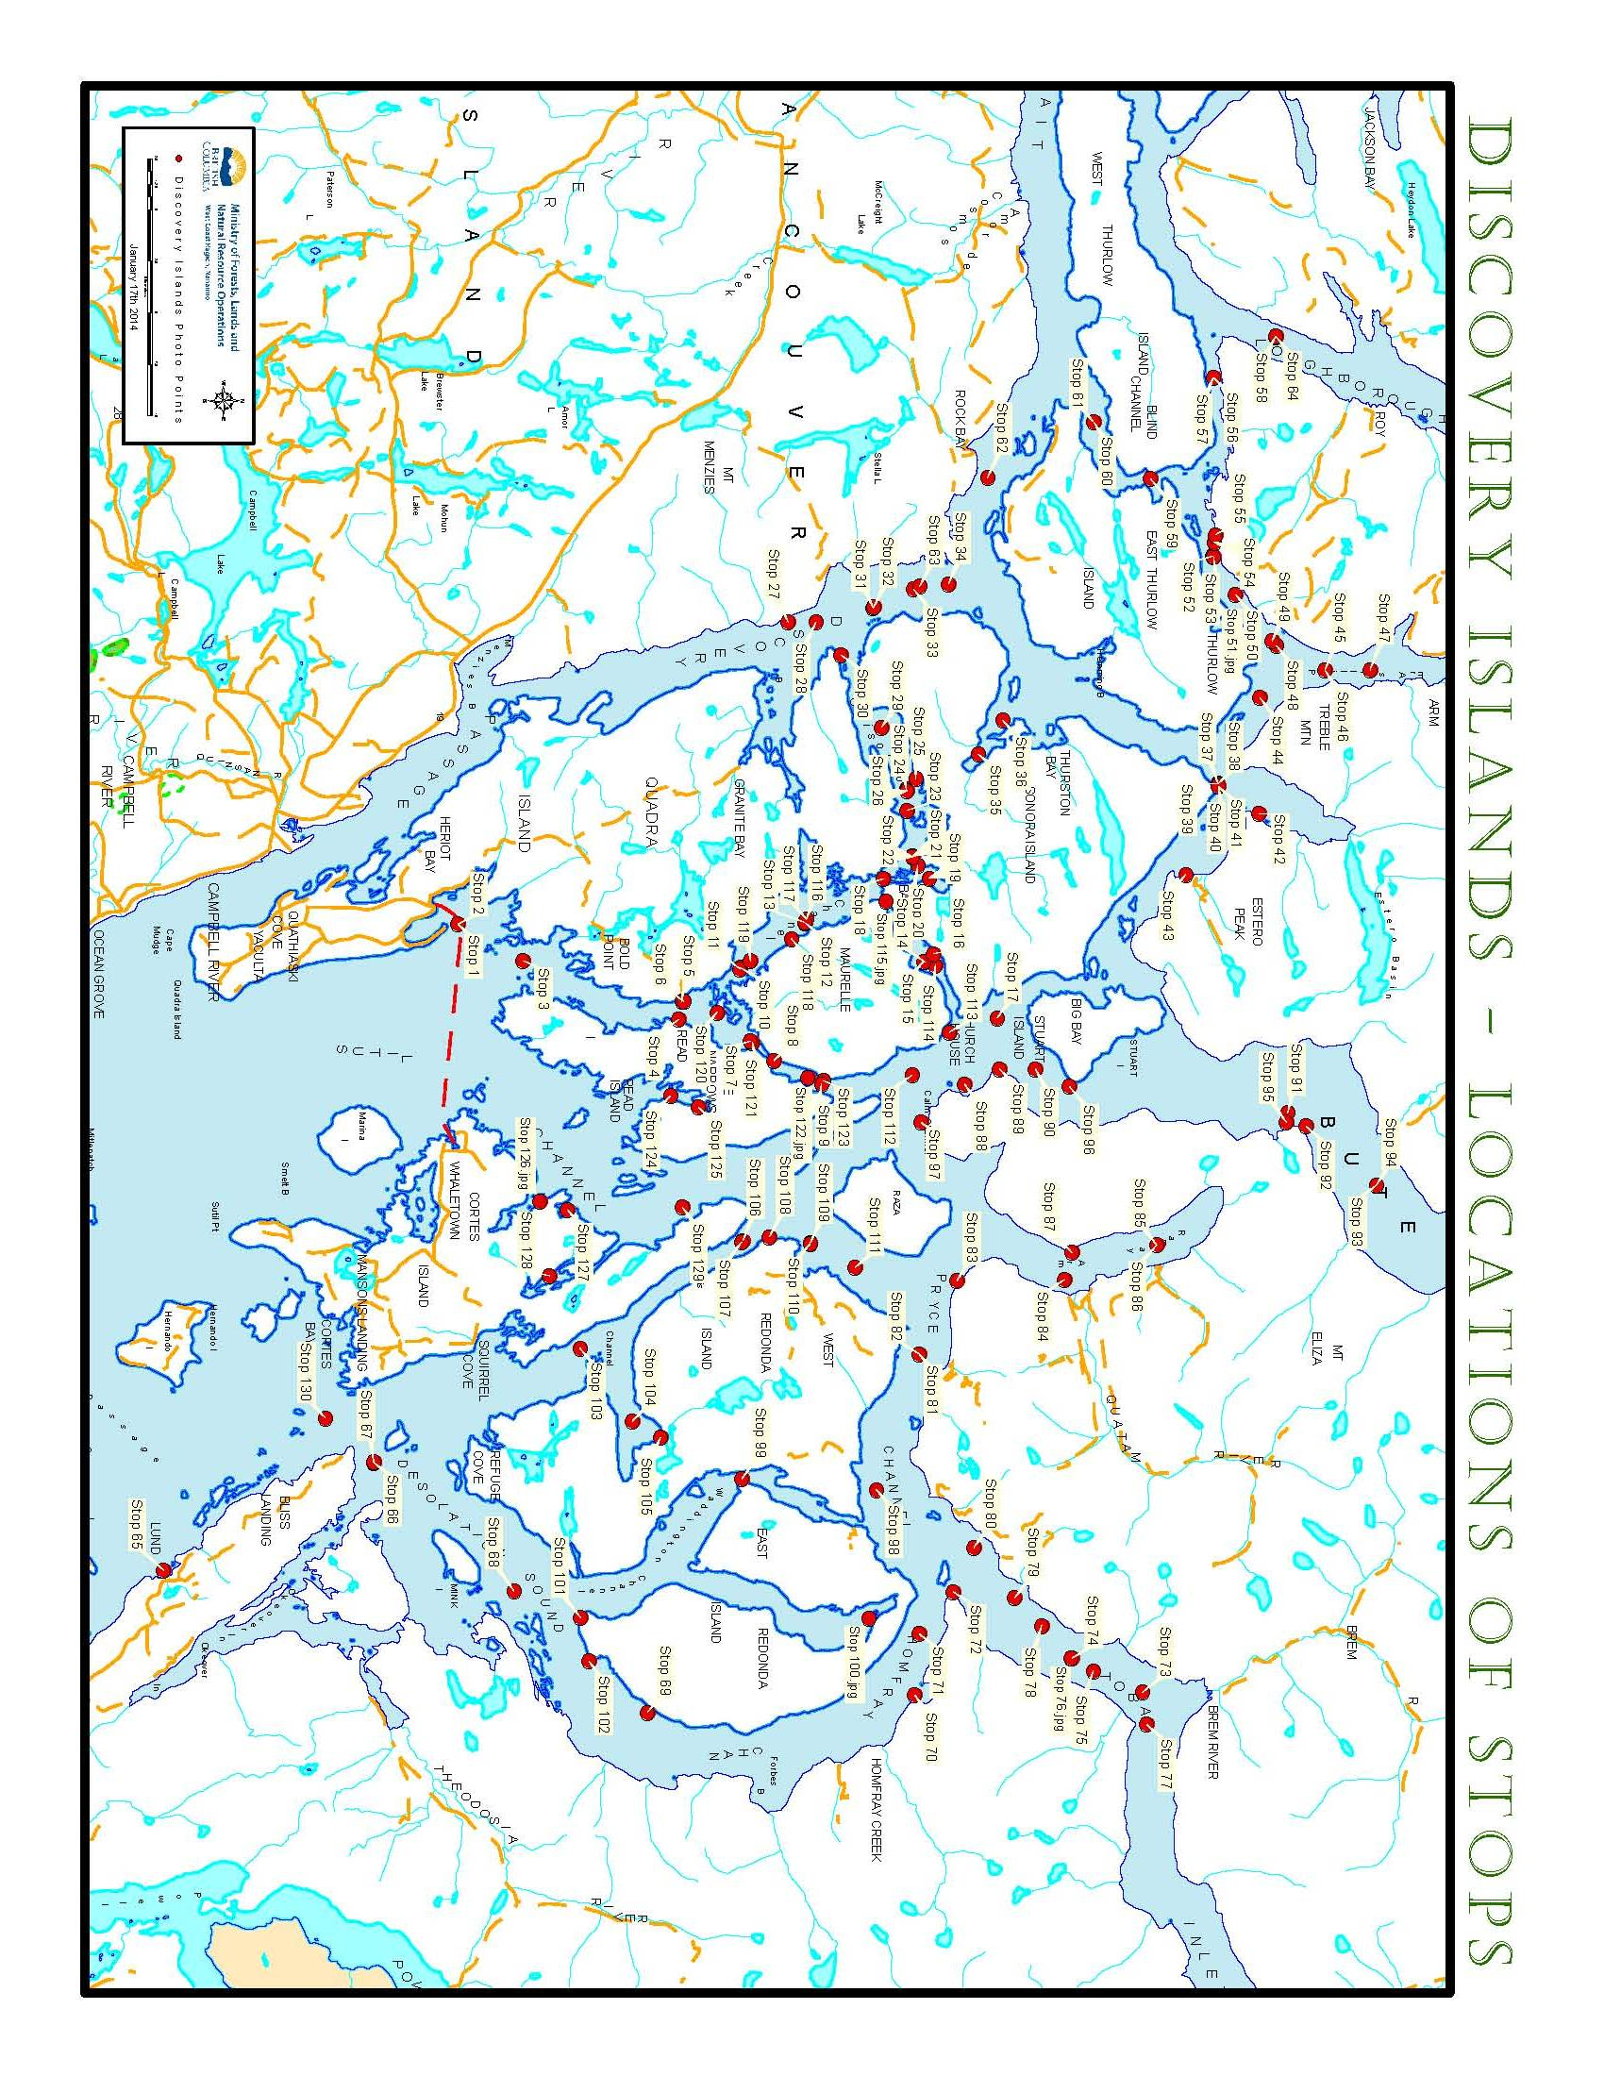
Appendix 4 Staff Contacts
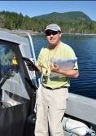

Lloyd Davies, RPF, Visual Resource Management Specialist
Coast Forest Area, MFLNRO
Lloyd.Davies@gov.bc.ca


John Andres, RPF, Stewardship Officer
Campbell River District, MFLNRO
John.Andres@.gov.bc.ca


Blake Fougere, RPF, Stewardship Officer
Sunshine Coast District, MFLNRO
Blake.Fougere@gov.bc.ca


Gerard Nachtegaele, RFT, Resource Technologist, Tenures
Sunshine Coast District, MFLNRO
gerard.nachtegaele@gov.bc.ca

